
FURTHER MATHEMATICS
TRIAL EXAMINATION 2
SOLUTIONS
2016

SECTION A - Core

Data analysis

Question 1 (5 marks)

- i. 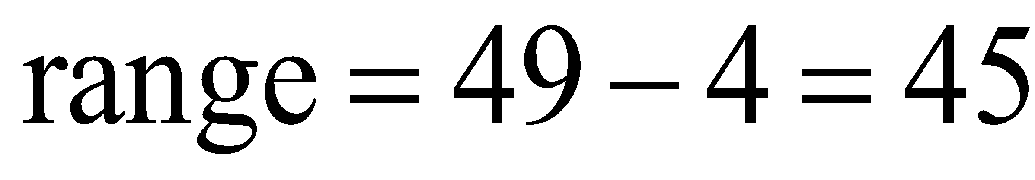
(1 mark)
ii.  (The mode is the most frequently occurring piece of data.)
(1 mark)
- On 3 days out of the 30 there were less than 20 cars travelling over the speed limit.
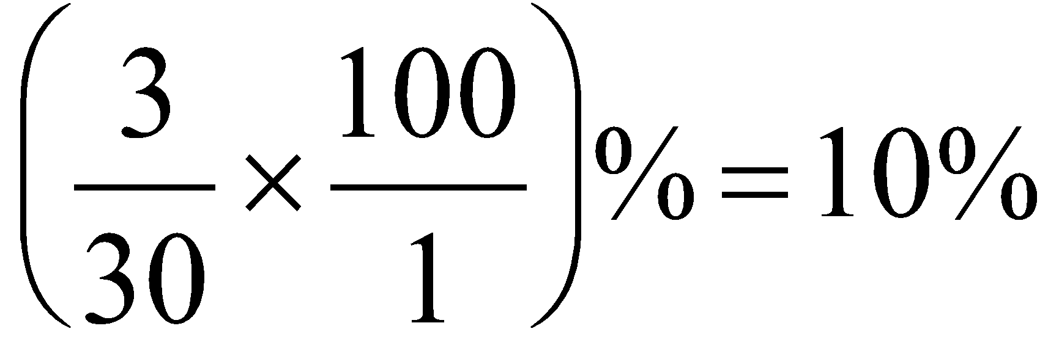
On 10% of days in June there were less than 20 cars travelling over the speed limit.
(1 mark)
c.
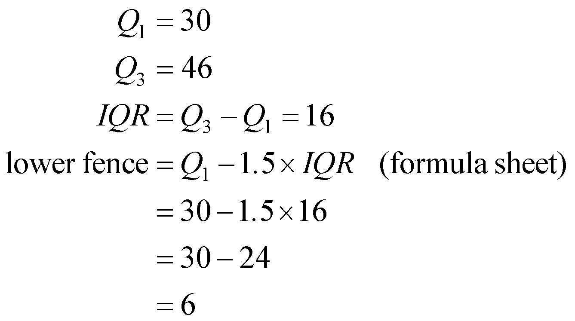
(1 mark)
Since 4 < 6 (you must state this!) then 4 is an outlier for this set of data.
(1 mark)

Question 2 (3 marks)

- The variable roadworthiness can be described as categorical and nominal.
(1 mark)
- The data does not support the opinion that the type of licence a driver has is associated with the roadworthiness of the car they drive.
(1 mark)
For example 85% of probationary drivers drove a roadworthy car and 87% of full licence drivers drove a roadworthy car which is not a significant difference.
(1 mark)
(Alternatively, 15% of probationary drivers drove an unroadworthy car and 13% of full licence drivers drove an unroadworthy car which is not a significant difference.
You would need a difference of at least 5% for it to be classified as significant.)
Question 3 (6 marks)

- The response variable is number of vehicles. (1 mark)

- The slope of the least squares regression line tells us that for every increase of one minute in time (that the gates are down) the number of vehicles waiting will increase by 4.3.
(1 mark)

- Since 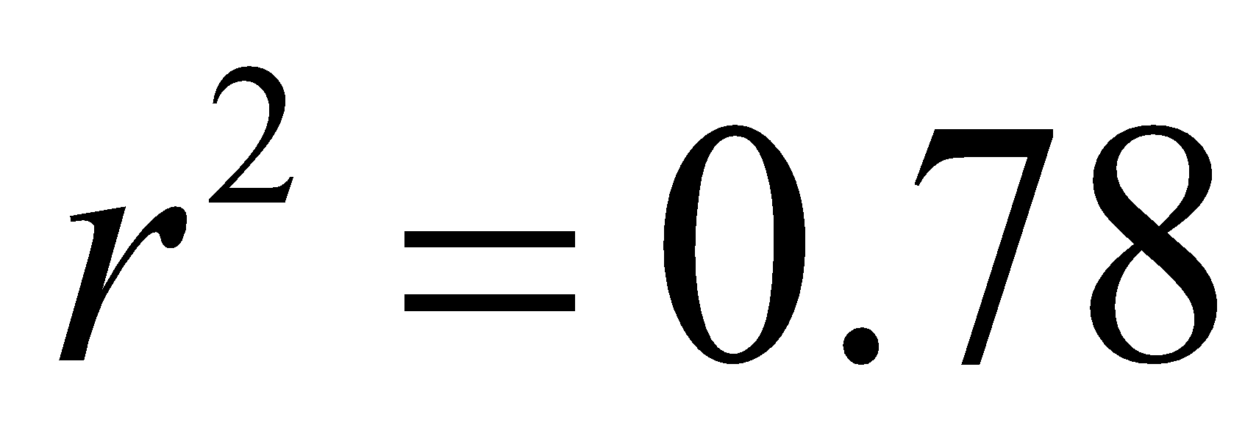, we know that 78% of the variation in the number of vehicles waiting can be explained by the variation in the time that the gates were down.
(1 mark)
- Pearson’s correlation is given by r.
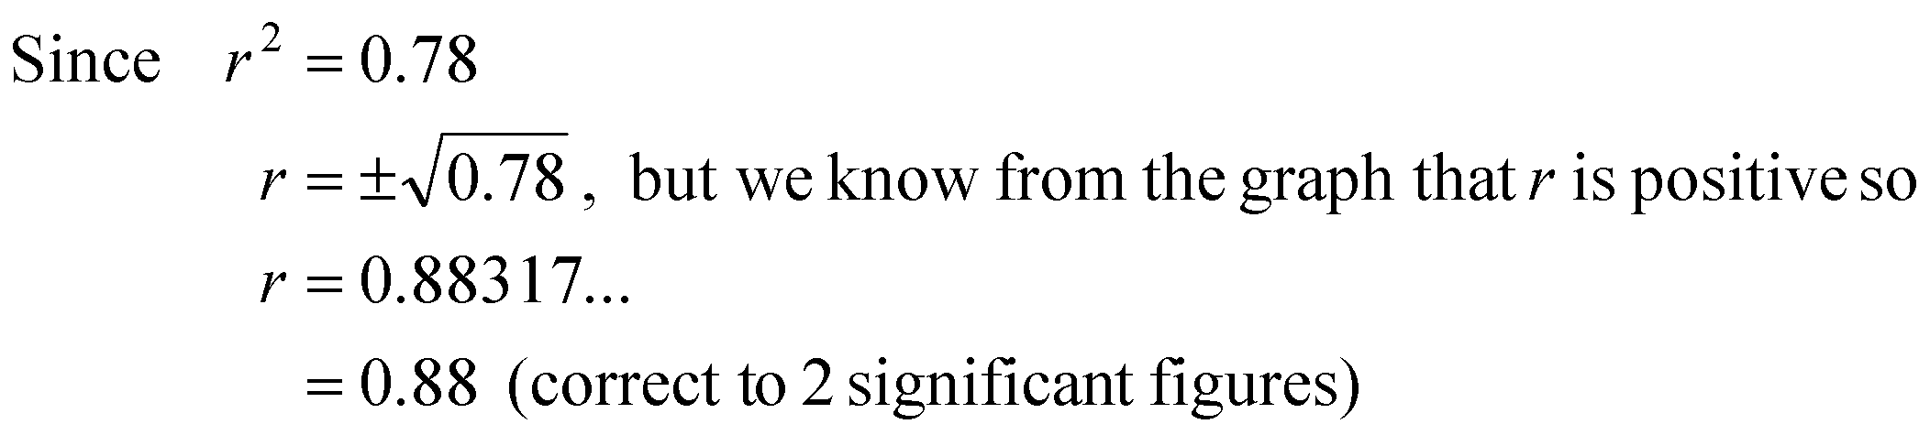
(1 mark)

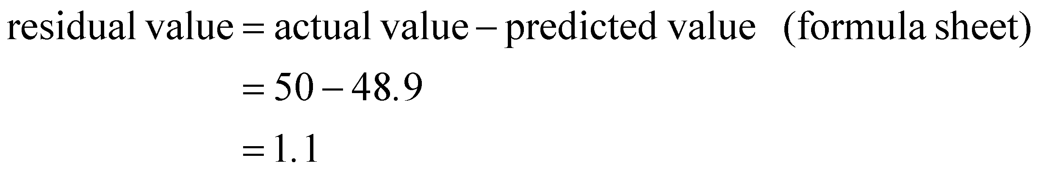
This point 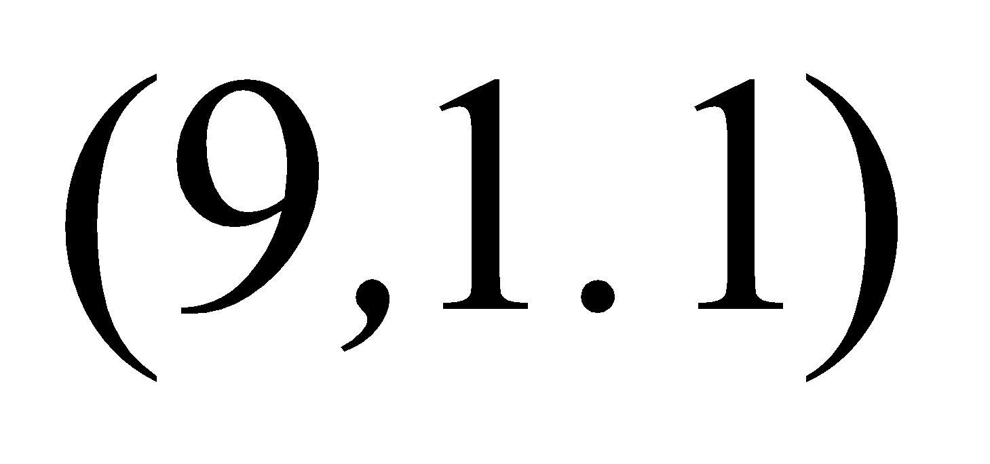is plotted and labelled on the residual plot below.
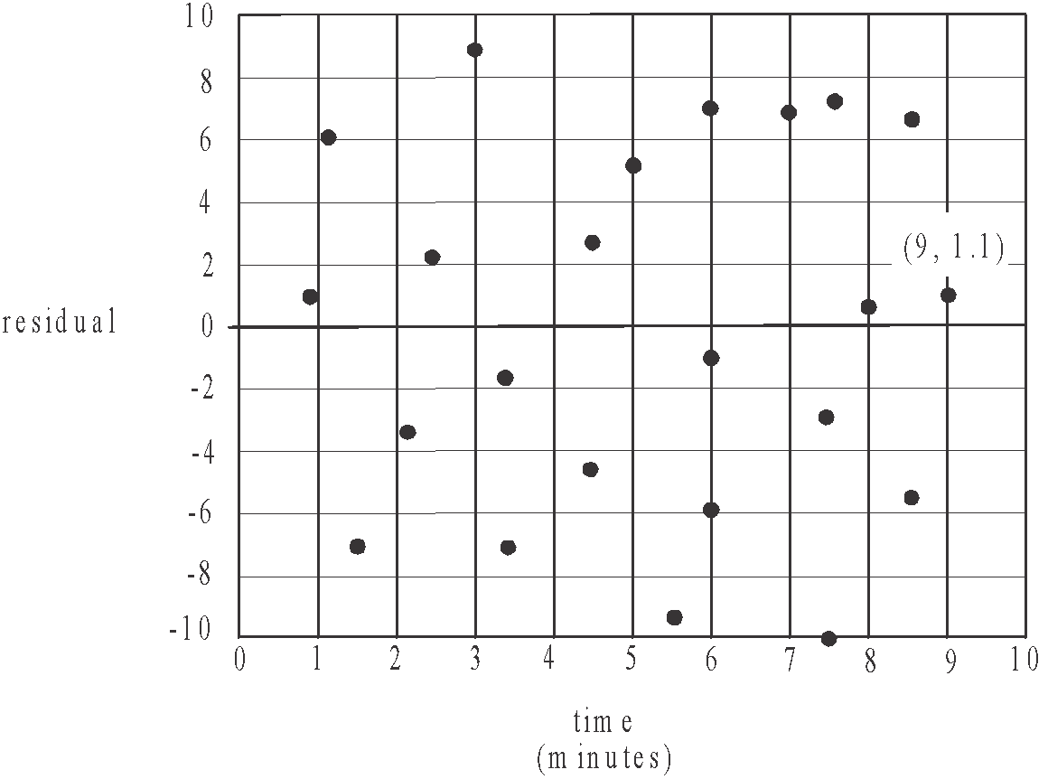

(1 mark)

- Because there is no clear pattern in the residual plot, the assumption of linearity is confirmed.
(1 mark)
Question 4 (3 marks)
- To obtain the coefficients in this equation, enter the data in the table and get your calculator to find (time)² for each of the data values of the variable time. This creates a third column of data. Calculate the least squares regression line equation using (time)² as the explanatory variable (x-variable) and number of vehicles as the response variable (y-variable).
So, where the coefficients have been expressed to two significant figures.
(1 mark) for –1.3 (1 mark) for 0.46
- When .
The number of vehicles predicted to be waiting when the gates are down for 4 minutes is 6 (to the nearest whole number).
(1 mark)
Question 5 (4 marks)
- The standardized z-score is given by 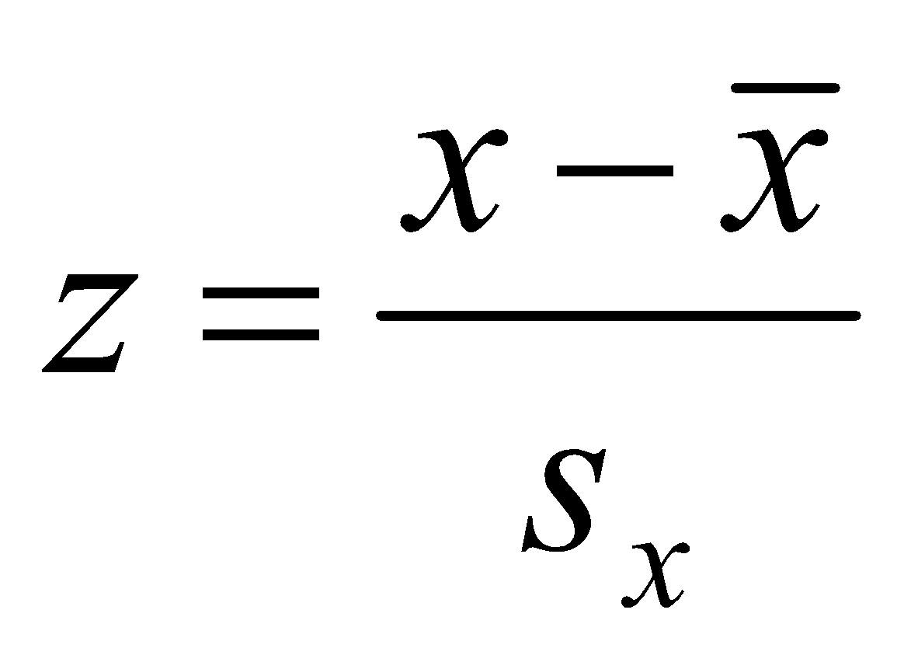 (formula sheet).
Be very, very careful here. This generic formula uses the variable x.
In the context of this question, the variable time has been referred to as the variable x and we are told it is the explanatory variable.
The variable number of vehicles has been referred to as the y variable. It is the response variable. It is this variable that we have been asked about in the question. So what we should be calculating is
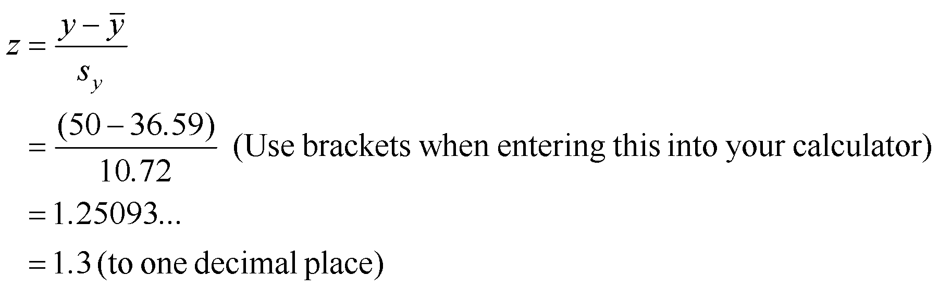 (1 mark)
- Again from the formula sheet, 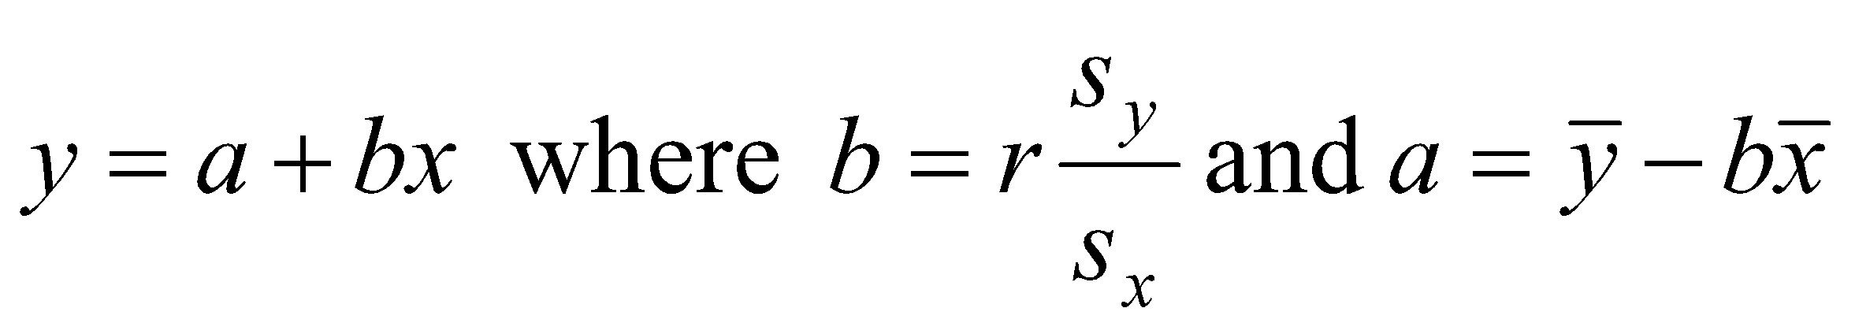.
Calculate b first (because we need the value b in order to find a).
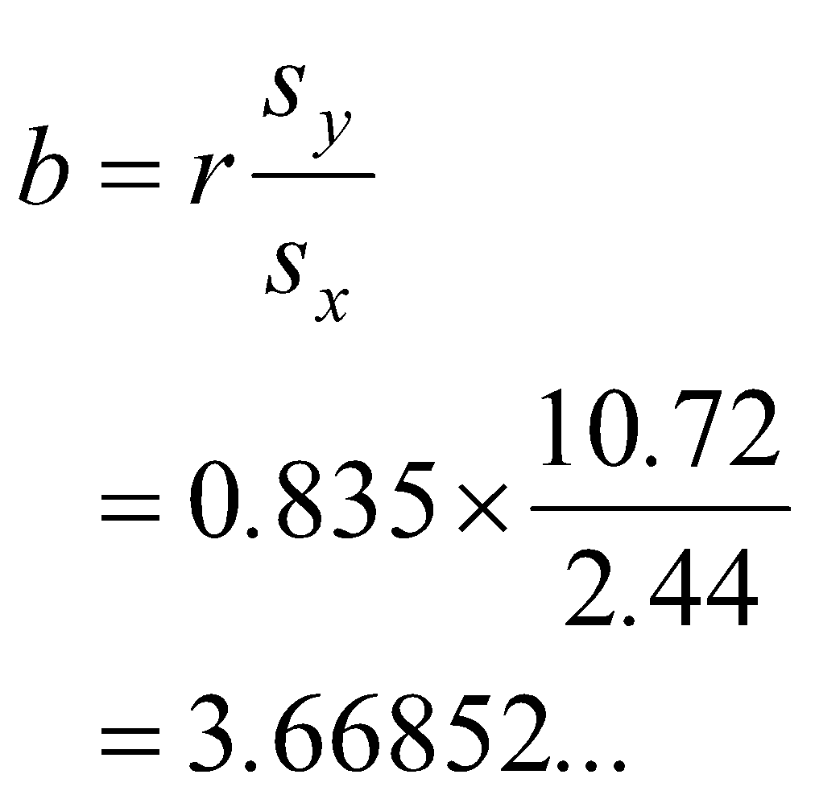
EMBED Equation.3

Equation of least squares regression line is where the coefficients (i.e. a and b) are expressed correct to three significant figures.
(1 mark) for correct intercept (1 mark) for correct slope

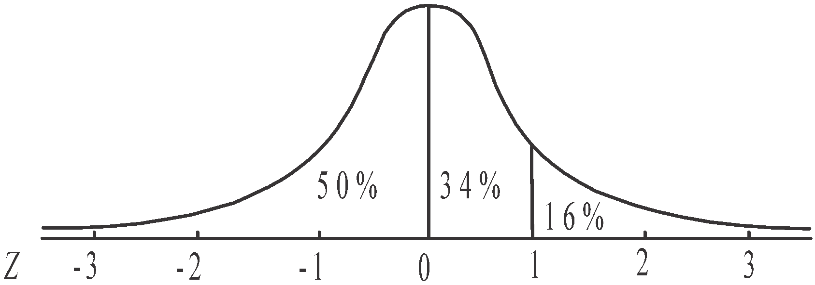
- From the diagram, we see that
16% of data lies above 1 standard
deviation above the mean.
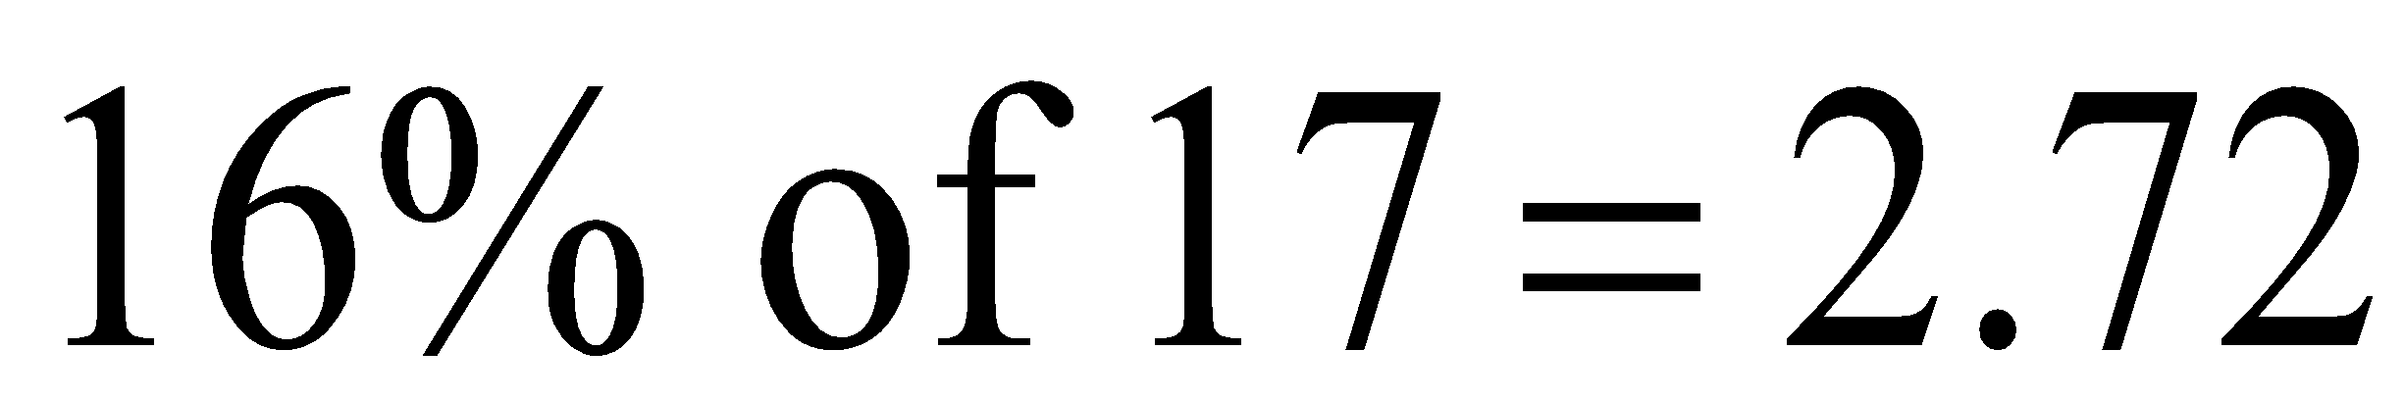
So 3 occasions (correct to the
nearest whole number) is the
required answer. (1 mark)
Question 6 (3 marks)

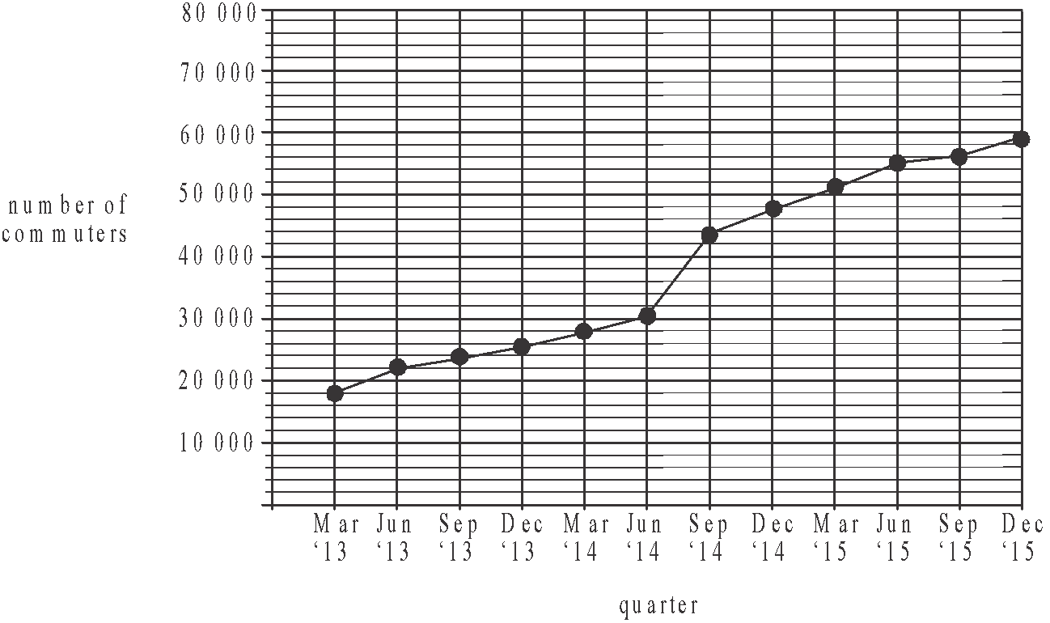

(1 mark)

- The time series plot shows an increasing trend between the quarters March 2013 to June 2014. There is a structural change between June 2014 and September 2014 when the number of commuters jumps dramatically.
There is an increasing trend between September 2014 and December 2015.
(1 mark)

- Finding the number of commuters predicted to use the station in 2020 requires extrapolating, that is, going beyond the data that we have used to create the least squares regressions line. It can therefore be unreliable.
(1 mark)
Recursion and financial modelling

Question 7 (4 marks)

- 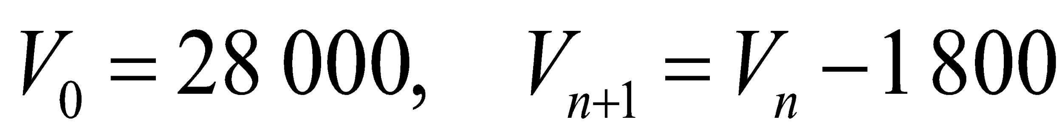
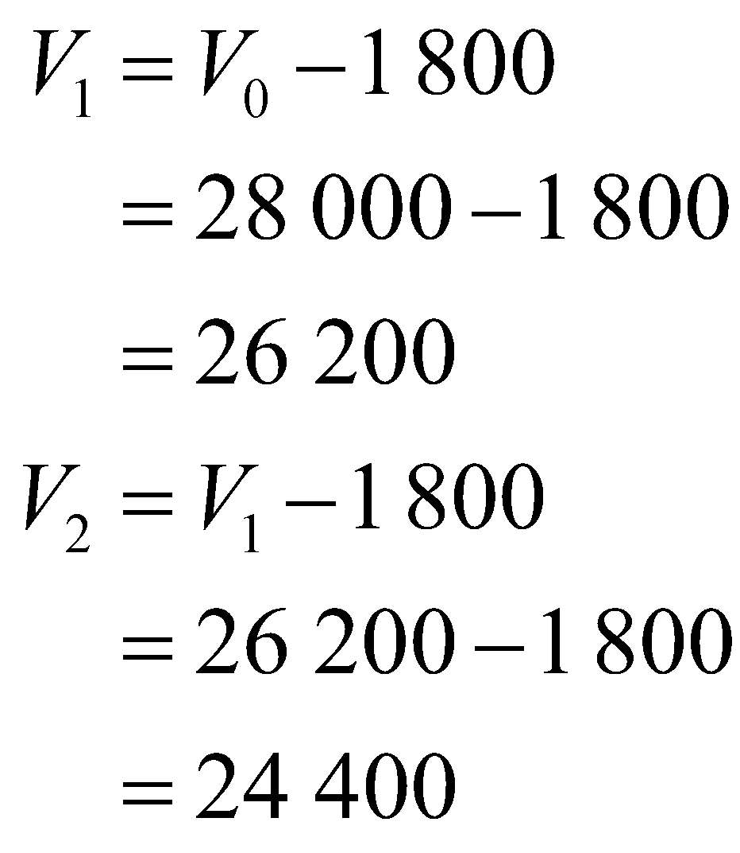
(1 mark)

- Generate the sequence on your CAS.
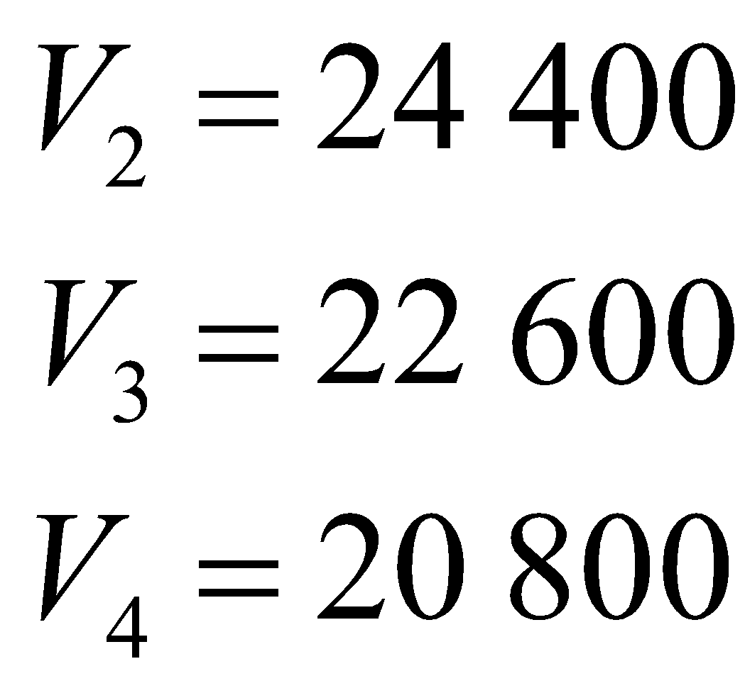
.
.
.
After 10 years the car will have a value of $10 000.
(1 mark)

- Generate this sequence on your CAS.
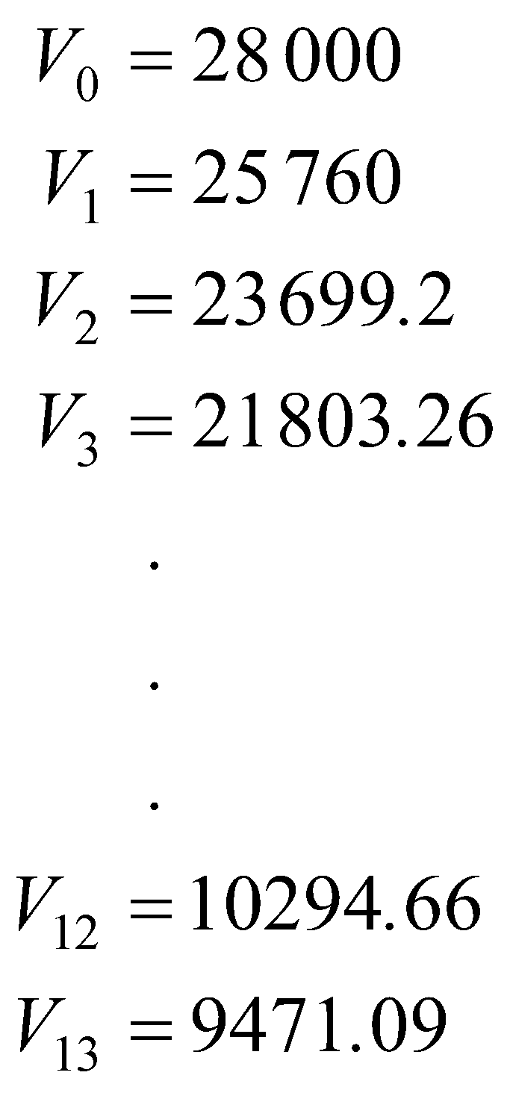
After 13 years the value first drops below $10 000.
(1 mark)

- From the recurrence relation, we see that the value of the car each year is 0.92 times the value of it the previous year. In other words it is being depreciated (or its value is decaying) by 8% of its value the previous year. The annual percentage rate of depreciation is 8%.
(1 mark)

Question 8 (4 marks)

- For a perpetuity, 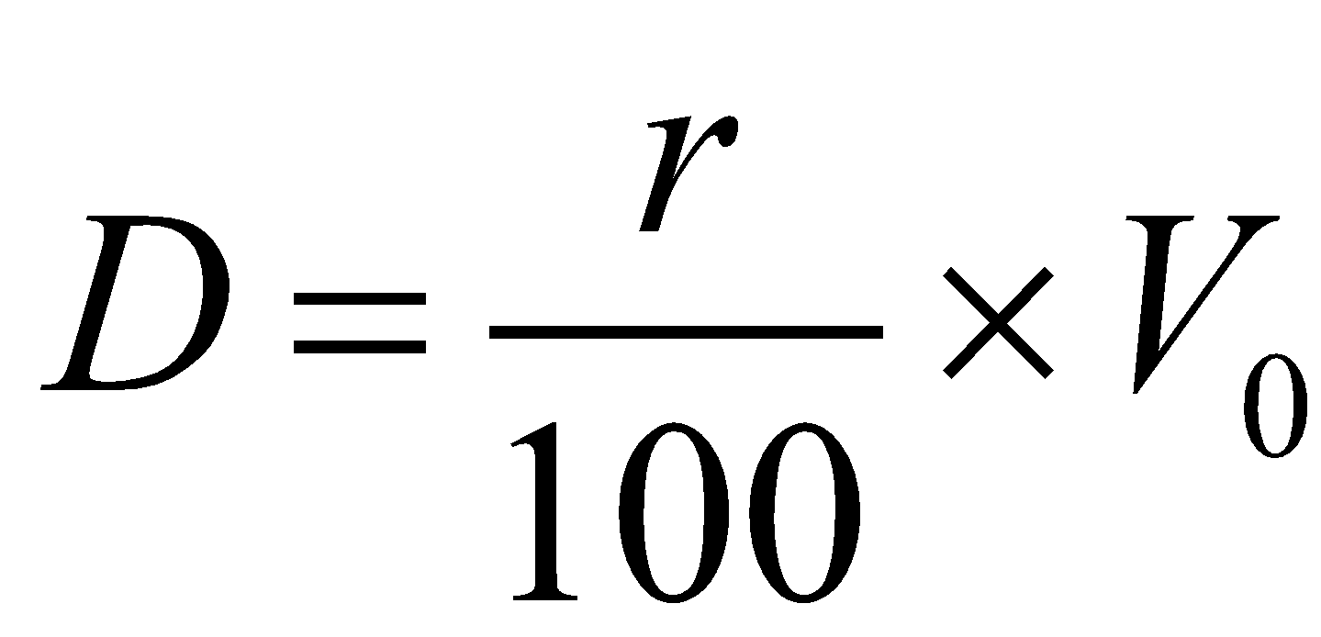 where D is the regular payment, r is the interest rate per period and V_{n} is the balance after n payments.
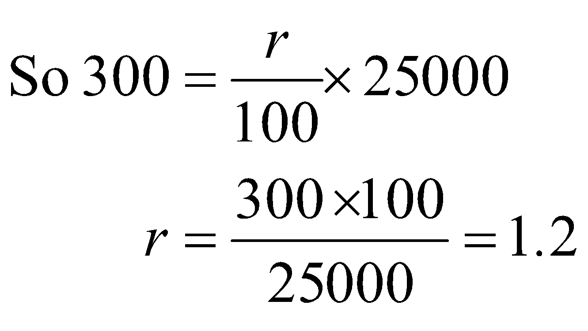
The rate per quarter is 1.2% so the annual interest rate is 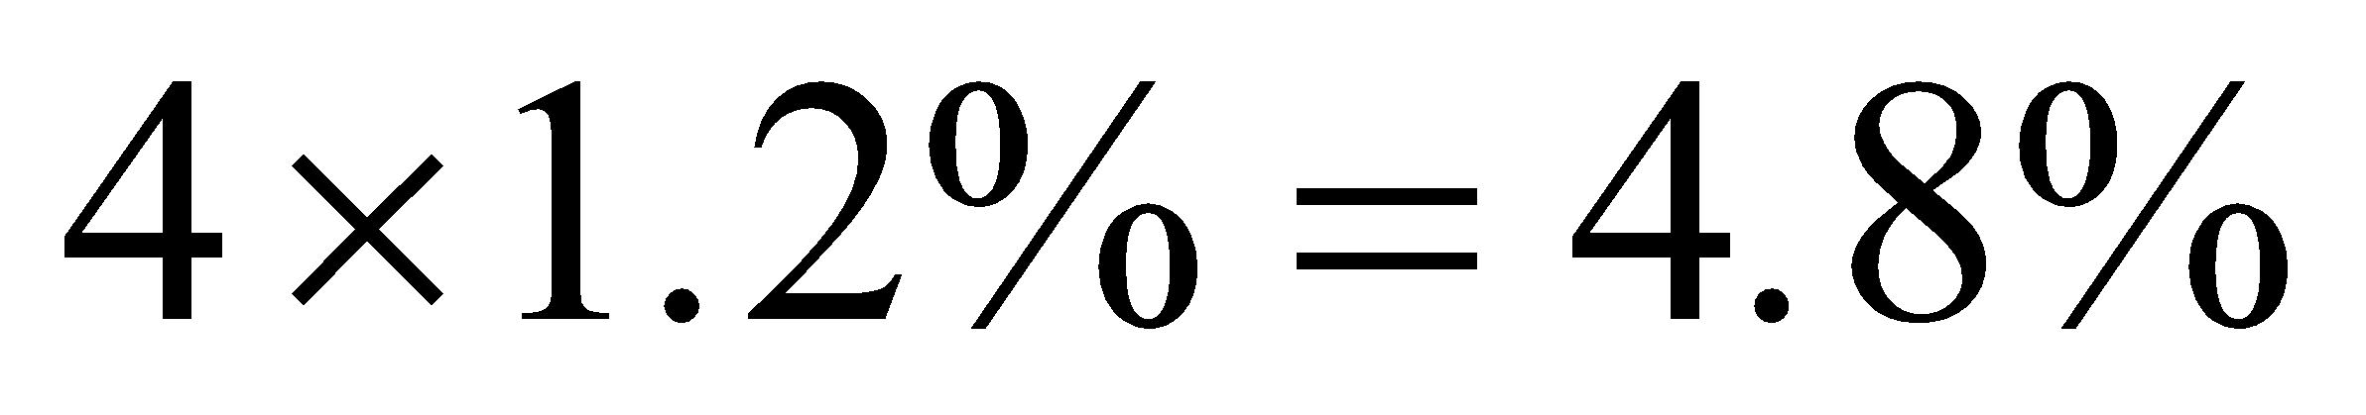.
(1 mark)

- i. V_{n} = the value of Jack’s investment after n quarters.
Interest rate per quarter 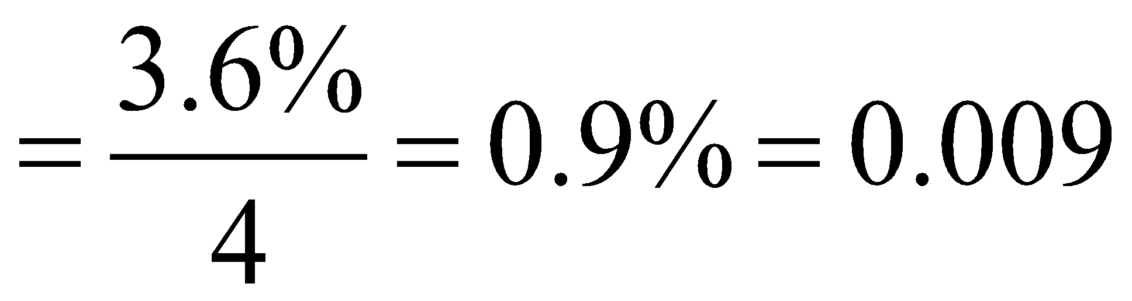
The rule for the relation is:
new value = current value + interest + payment
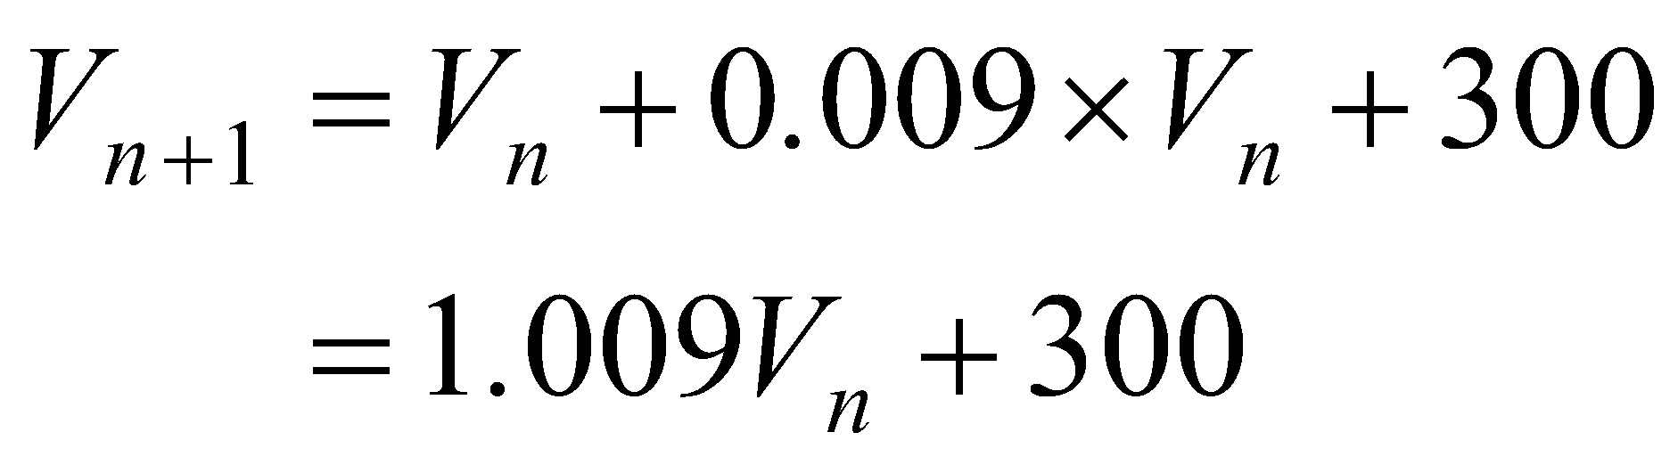
The required recurrence relation is
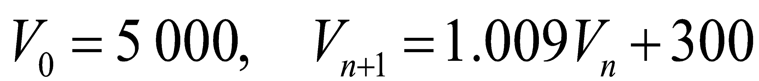
(1 mark)

- Using TVM,
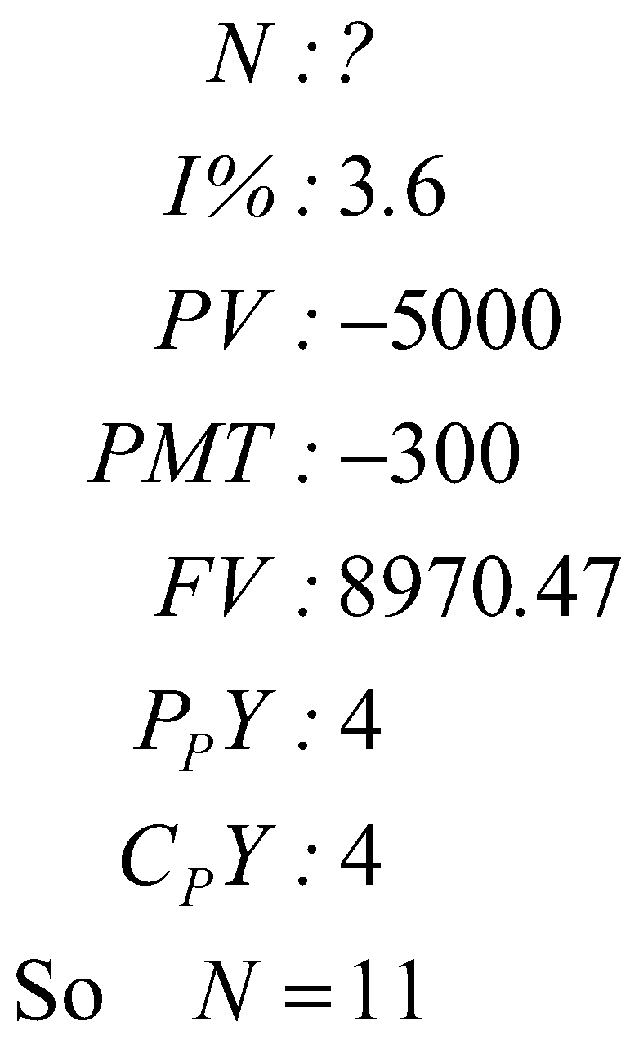
(1 mark)

It took 11 quarters for the investment to reach a value of $8 970.47. After 11 quarters Jack had invested 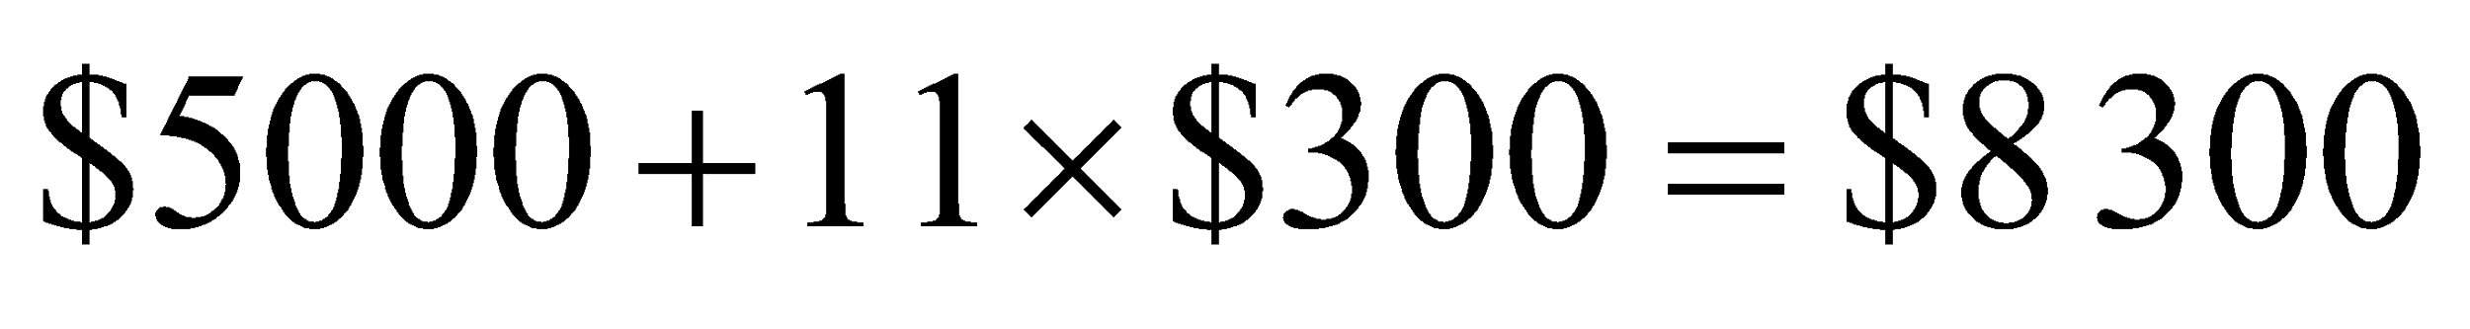.
So 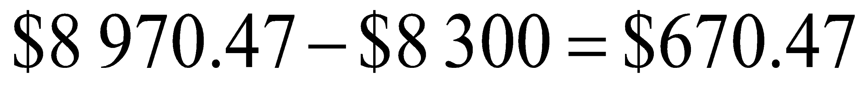 of interest had been earned.
(1 mark)
Question 9 (4 marks)
- Using TVM,
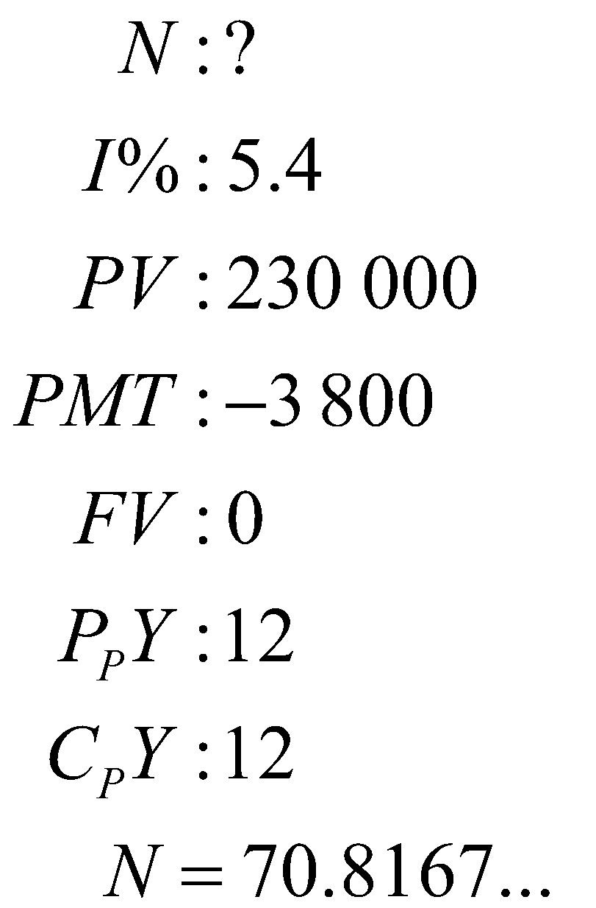
So 71 monthly repayments (to the nearest whole number) must be made. (1 mark)
- Using TVM,
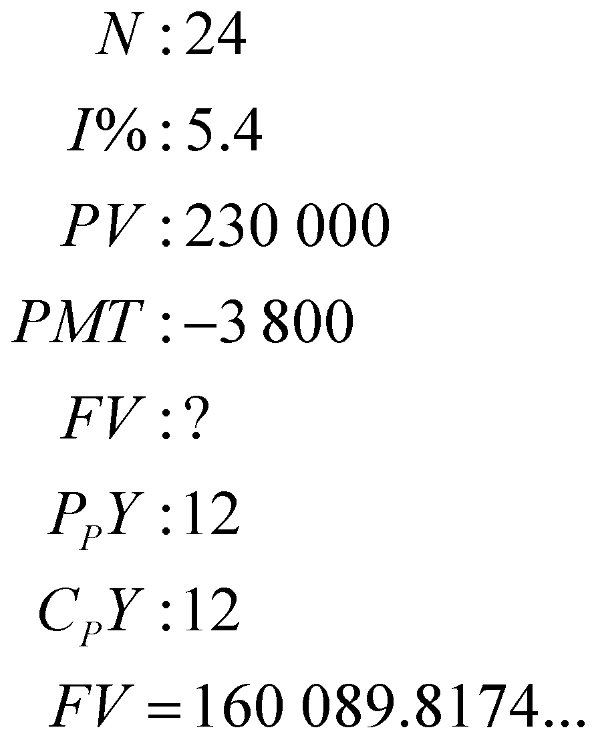
After 2 years (24 months) the amount still owing on the loan is $160 089.82.
The amount paid off the principal is $230 000 - $160 089.82 = $69 910.18. (1 mark)
- From part b, the amount still owing on the loan after 2 years was $160 089.82.
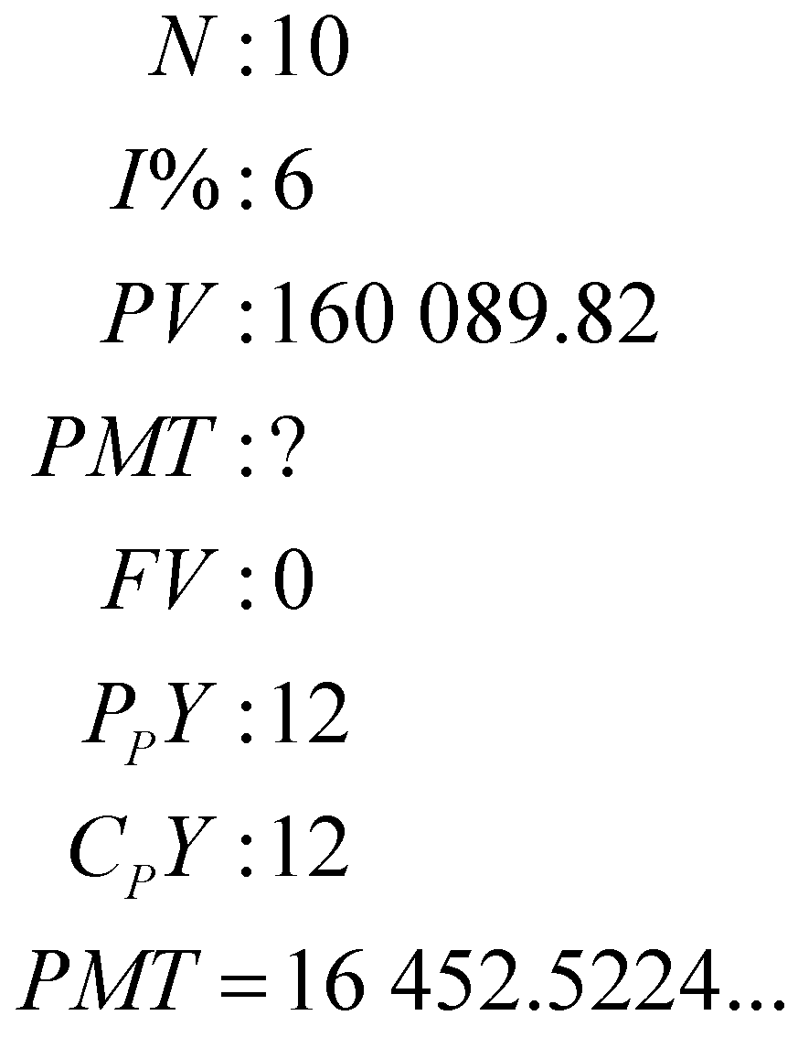
Jack’s next repayment is $16 452.52. (1 mark)
d. Using TVM
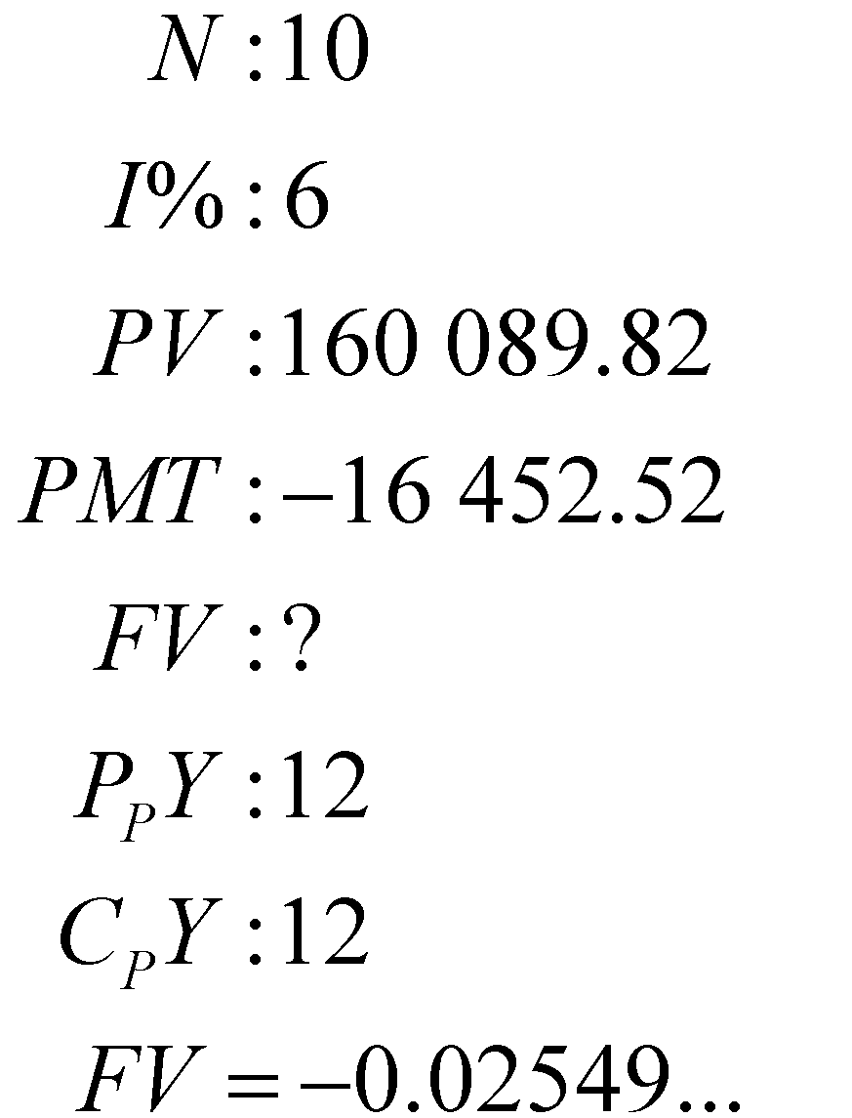
The amount still owing after the 10 repayments is $0.03 or 3 cents. This is because repayments have to be made in legal tender, that is, you can’t pay back
$16 452.5224…, it must be $16 452.52. This means there is a slight adjustment to be made with the last payment. In this case it is just an addition of 3 cents. Jack’s final repayment is $16 452.55. (1 mark)
SECTION B - Modules

Module 1: Matrices

Question 1 (5 marks)

- 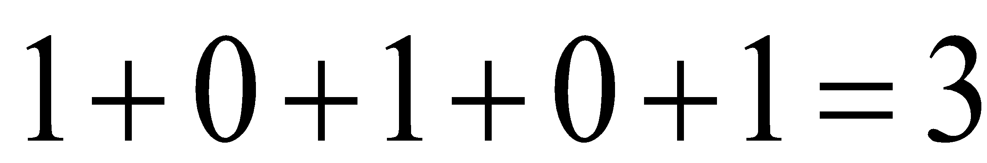
(1 mark)

- It represents that Maddie is in direct contact with three members of the group.
(1 mark)

- To obtain the two-step communication link matrix we square the one-step communication link matrix.
That is,
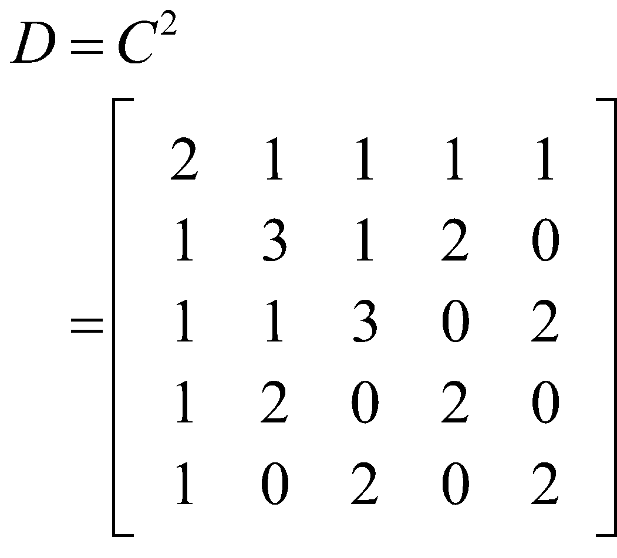
The missing entries are both 2.
(1 mark)

- The entries in the leading diagonal of matrix D represent a communication link between the same person not between two different people.
(1 mark)
(Such links are said to be redundant because they tell us nothing about the communication links between different people, hence we ignore them).

- As mentioned in part d., we ignore the elements in the leading diagonal because they don’t represent links between two different people. A line has been drawn through them below.

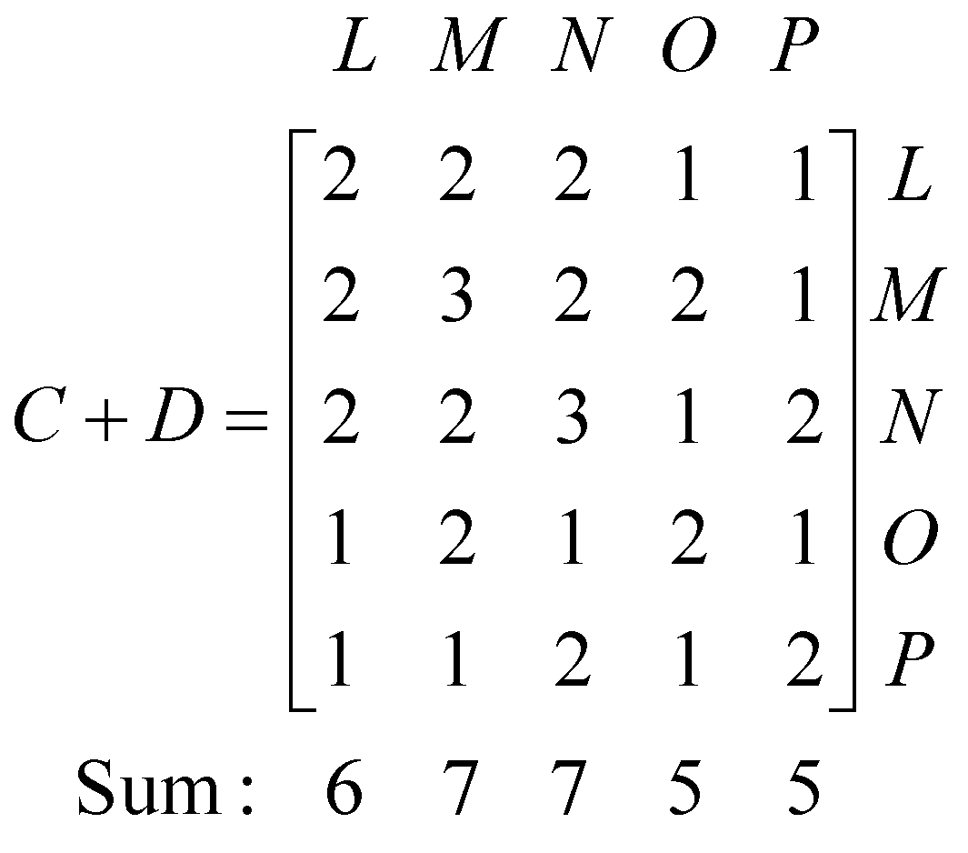
By summing the columns of the matrix C + D (ignoring those elements in the leading diagonal) we see that Maddie and Nora have the most links to other members of the group, that is, they each have 7 links.
(1 mark)

Question 2 (7 marks)

- The proportion of cleaning staff who are expected to leave the ship after the first cruise is 0.20. This means that 20% of the 130 cleaning staff who are on board the ship prior to the first cruise will leave the ship.
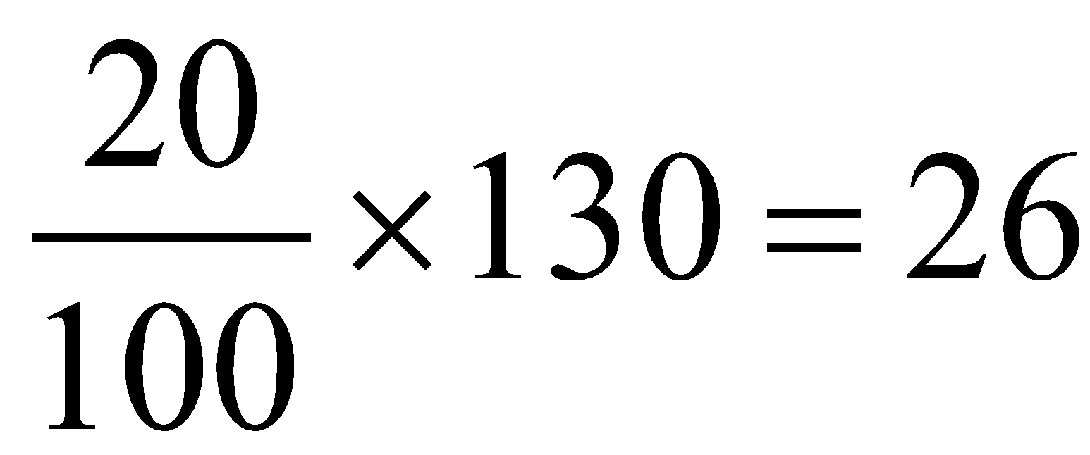
So 26 cleaning staff are expected to leave the ship after the first cruise.
(1 mark)

- We know from part a., that 26 cleaning staff are expected to leave after the first cruise. Similarly 10% of bar staff i.e. 10% of 50 = 5 bar staff are expected to leave. No kitchen staff are expected to leave.
So in total, it is expected that management will have to employ 31 new hospitality staff after the first cruise in order to keep the total number of hospitality staff constant. (1 mark)

- There are 10 pieces of information (i.e. non-zero numbers) in the transition matrix that must be represented by arrows on the transition diagram.
There are currently 9 on the diagram. The one that is missing runs from C to B (15%) as shown on the diagram below.

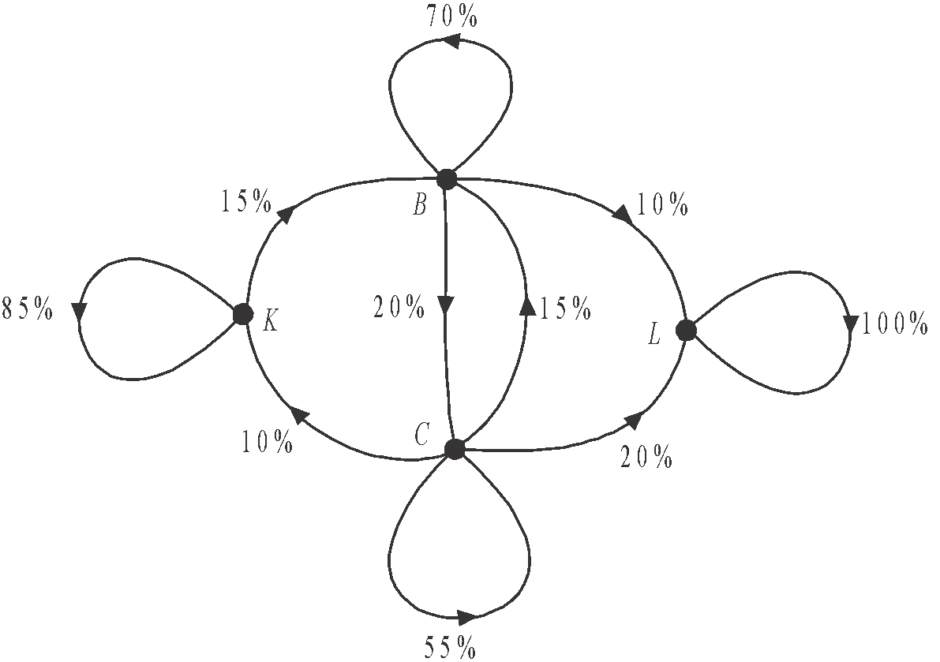

(1 mark)
- Since 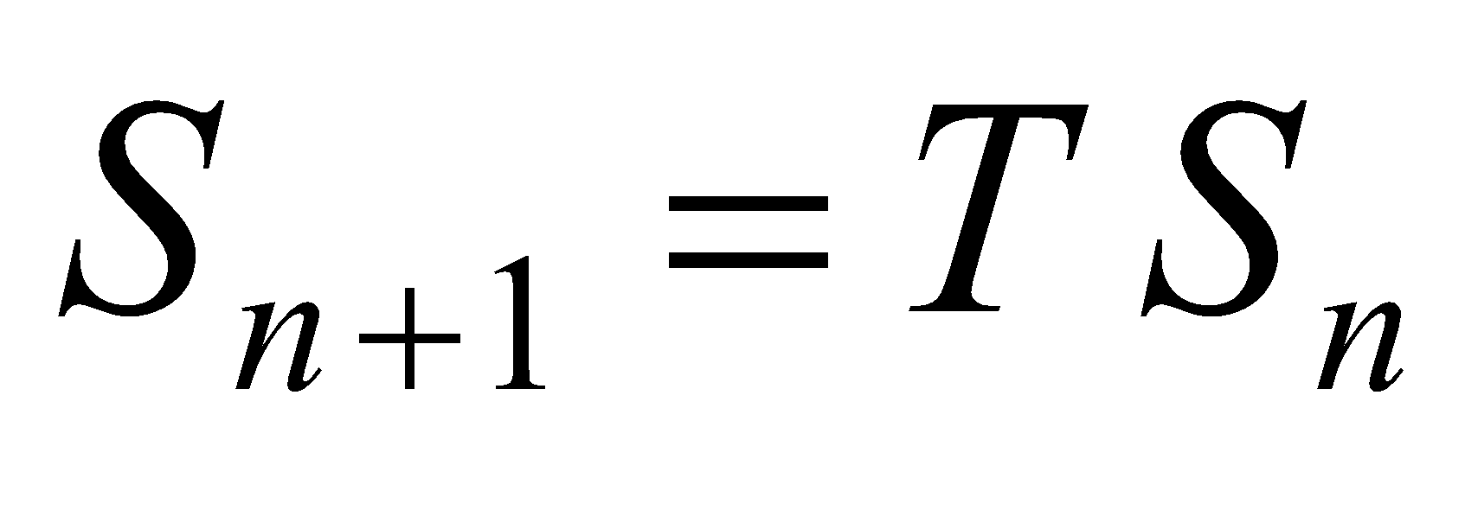, then we can use the rule 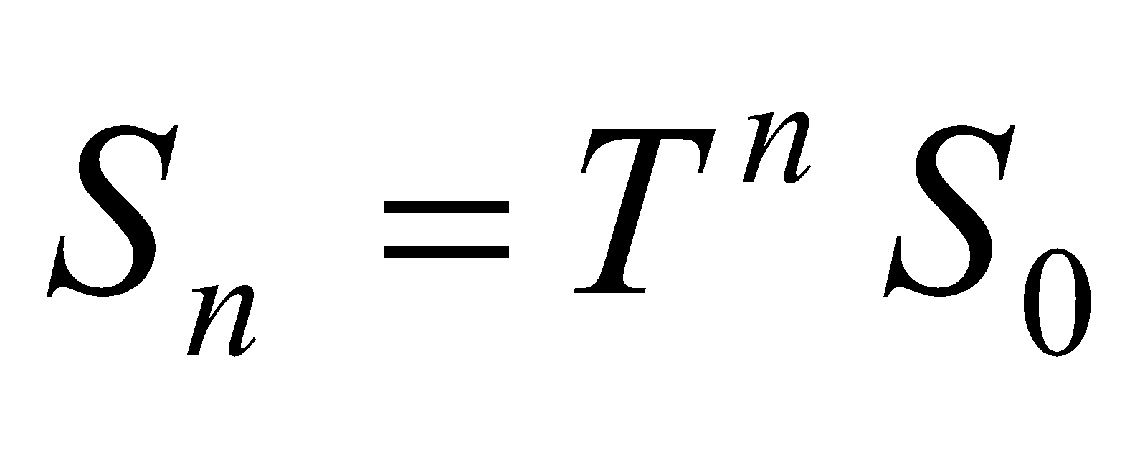 to find .
Use your calculator to calculate
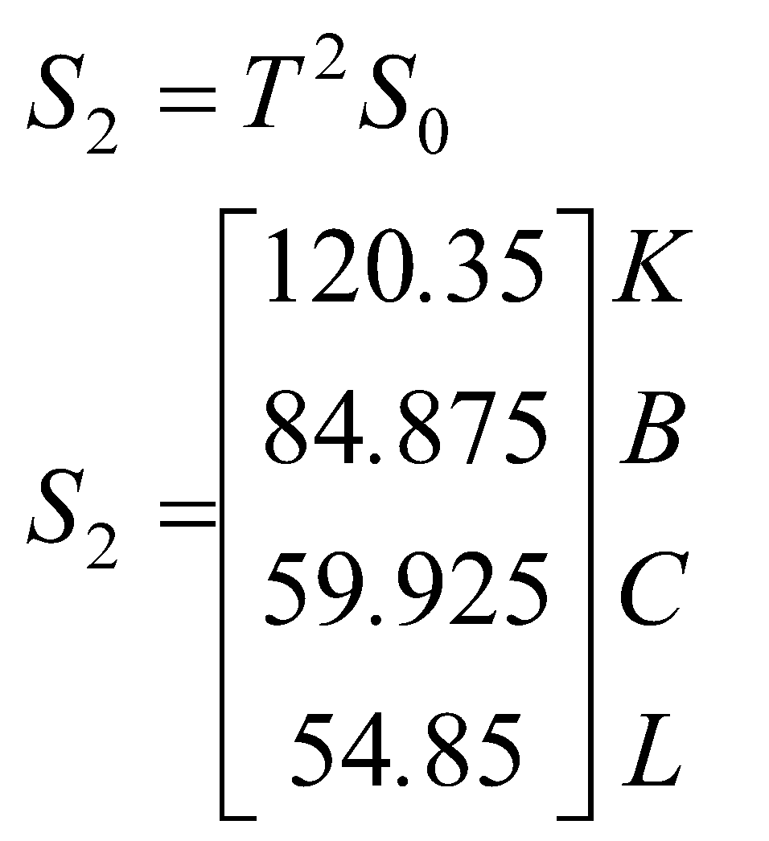
After the second cruise there is expected to be 60 cleaning staff (to the nearest whole number) on the ship.
(1 mark)
- The original number of staff was 320. When more than 160 staff have left, the number of staff will have dropped below half the original number.
Use trial and error with the rule
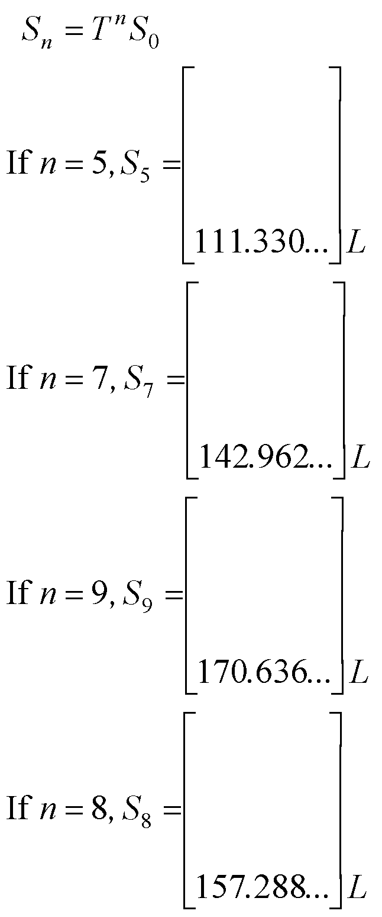
So after the 9th cruise 171 staff (to the nearest whole number) would have left the ship and this is the first time that more than 160 staff had left and therefore the first time that the number of staff had dropped below half the original number of 320.
(1 mark)

- 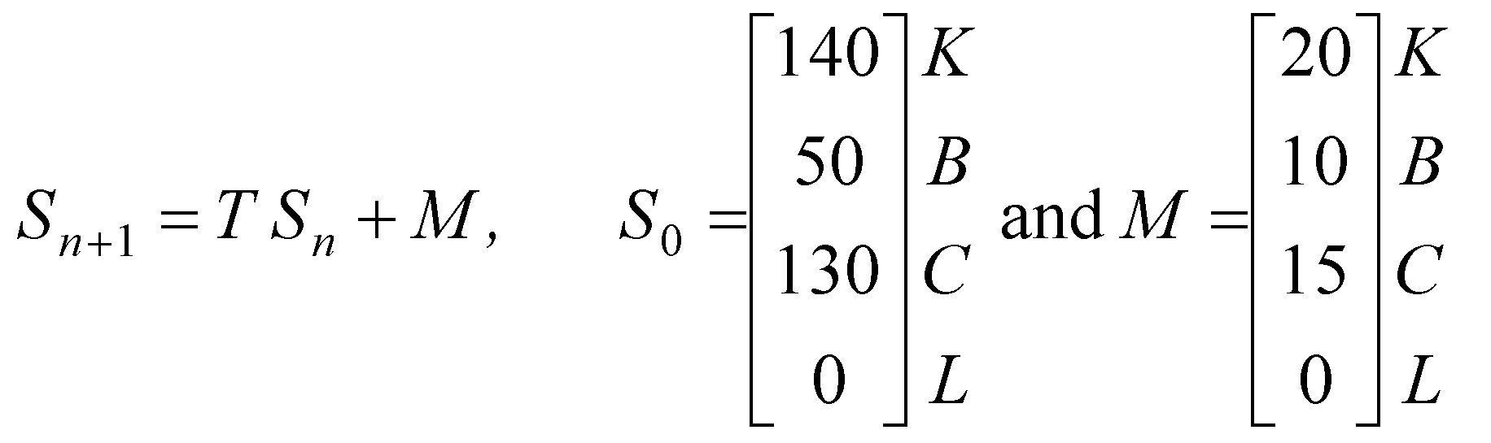
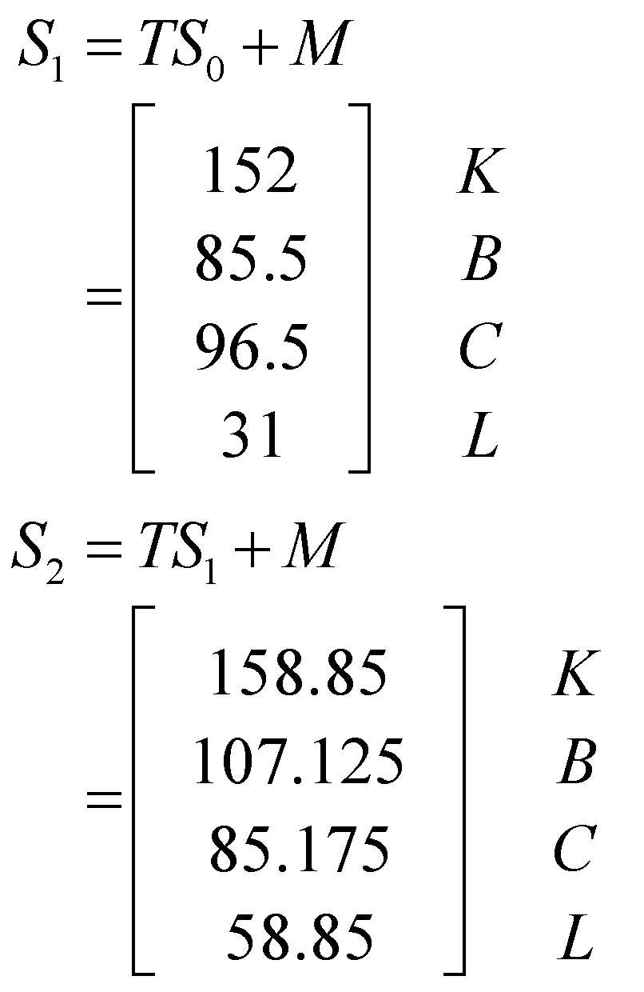 (1 mark)
So after the 2nd cruise there are expected to be 85 (to the nearest whole number) cleaning staff on the ship.
(1 mark)

Module 2: Networks and decision mathematics

Question 1 (4 marks)

(1 mark)

- This is the case because the degree of every vertex of this connected graph is even.
(1 mark)
(NB. – an Eulerian circuit follows every edge just once and starts and finishes at the same vertex).

- The route contains no repeated edges, no repeated vertices and starts and finishes at the same vertex so it is a cycle.
Note that it is not a Hamiltonian cycle because it doesn’t visit every vertex, that is, it doesn’t visit vertex D.
(1 mark)

- A Hamiltonian path visits every vertex on the graph.
Two possible answers are ACFGEDB or ACDFGEB.
(1 mark)

Question 2 (2 marks)

There are many different ways to apply Djikstra’s algorithm. One of these ways is shown below.
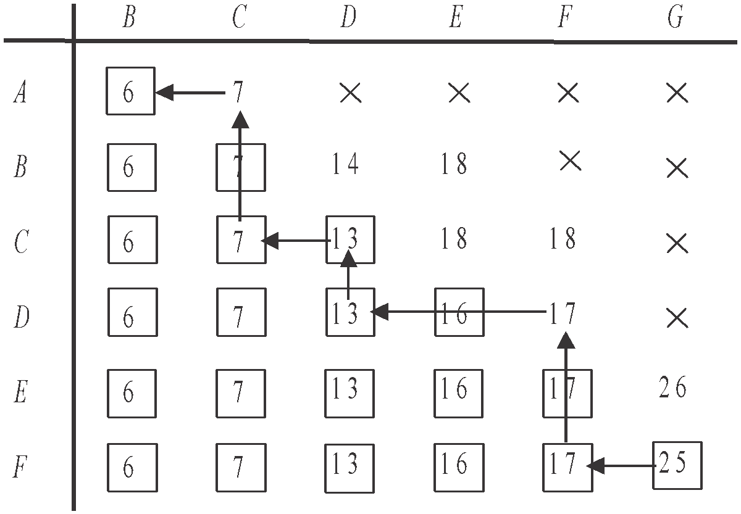

- The shortest distance is 25 km.
(1 mark) - shortest distance and evidence of
having used Djikstra’s algorithm

- The shortest route is ACDFG.

(1 mark) – shortest route and evidence of
having used Djikstra’s algorithm
Question 3 (6 marks)
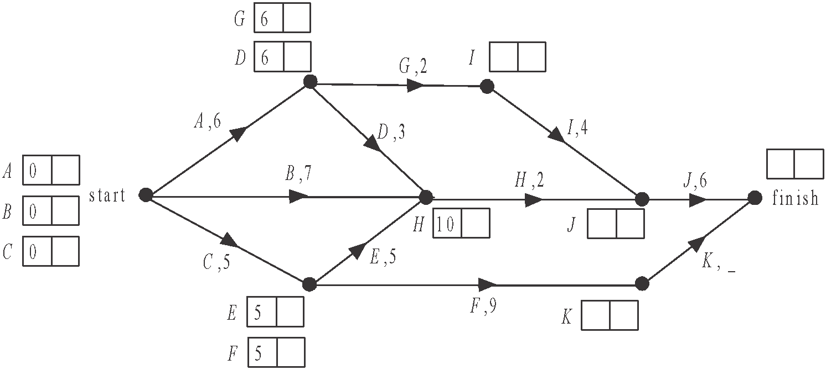

- Start a forward scan (shown above). This shows that the earliest start time for activity H is 10 days.
(1 mark)

- Complete the scan. We are told that the minimum completion time for the project is 19 days.
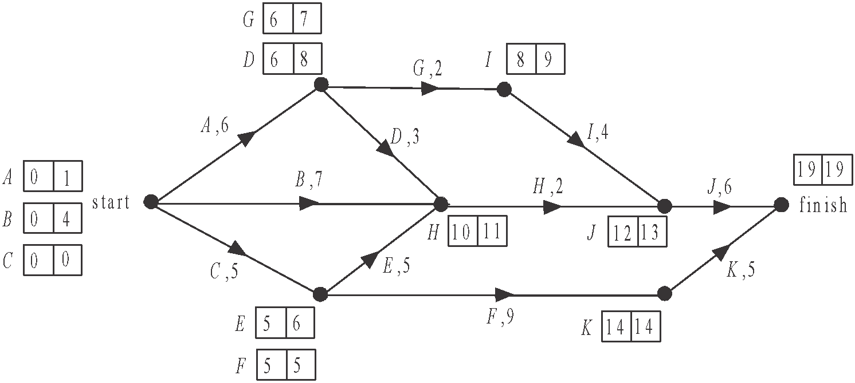

The earliest start time for J is 12 days and the duration of J is 6 days which gives a total of 18 days. The critical path must therefore include activity K and 19 – 14 = 5 so the duration of activity K is 5 days.
(1 mark)

- Using the backward scan shown on the diagram above, the latest start time for activity A is 1 day.
(1 mark)

- From the diagram in part b., the critical path is C, F, K.
(1 mark)

- i. Add a dummy activity as shown.
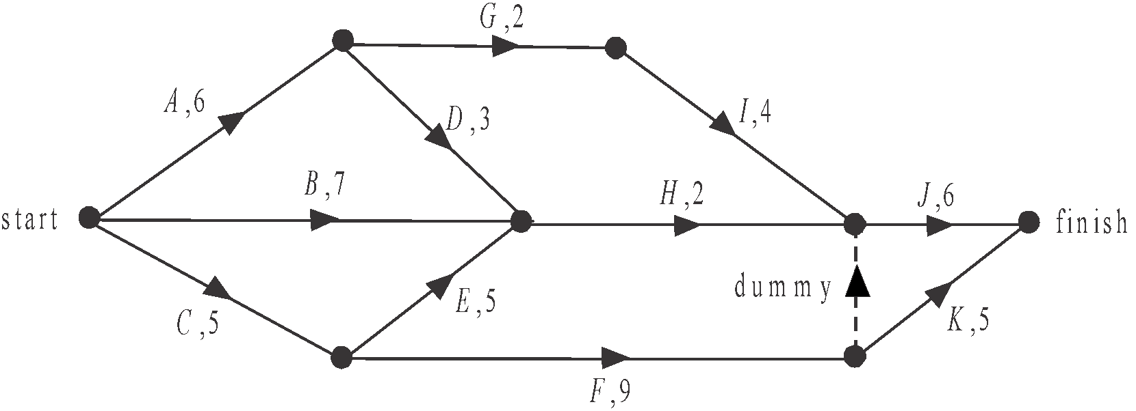

(1 mark)

- Do a forward scan for this changed network.

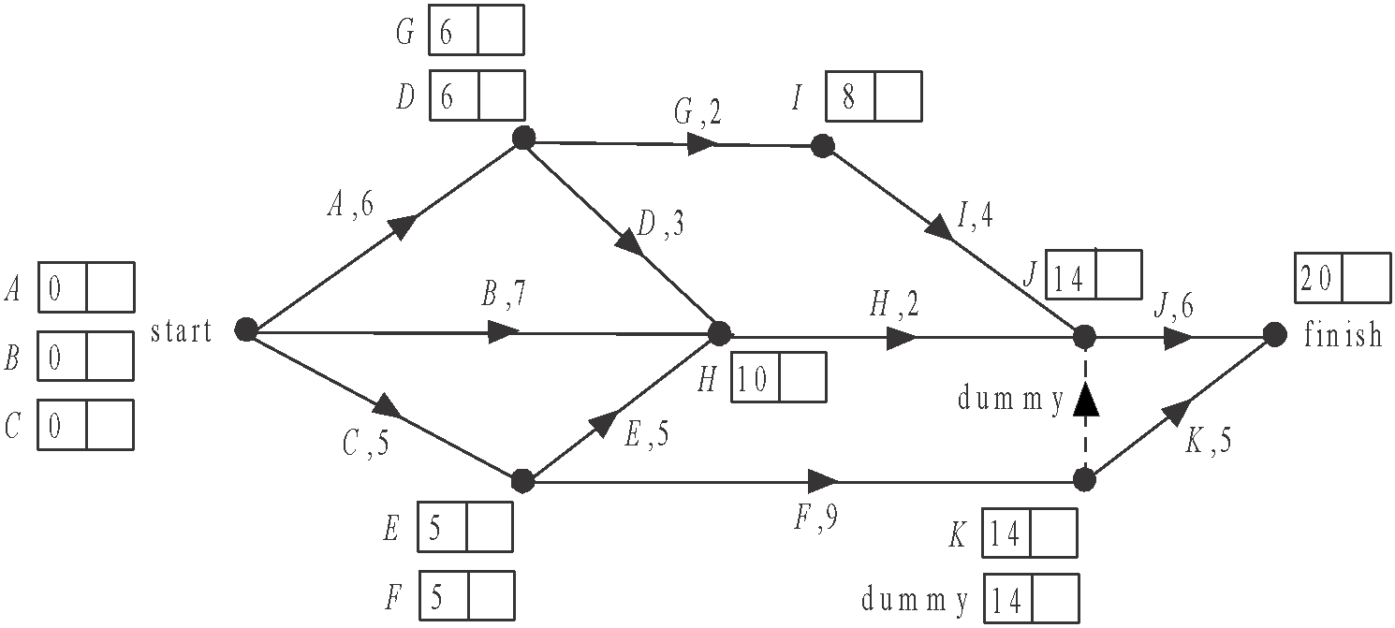

From part b., we know that activity K has a duration of 5 days.
The minimum completion time is changed to 20 days. So this change has increased the minimum completion time by 1 day.
(1 mark)

Module 3: Geometry and measurement

Question 1 (2 marks)

a.
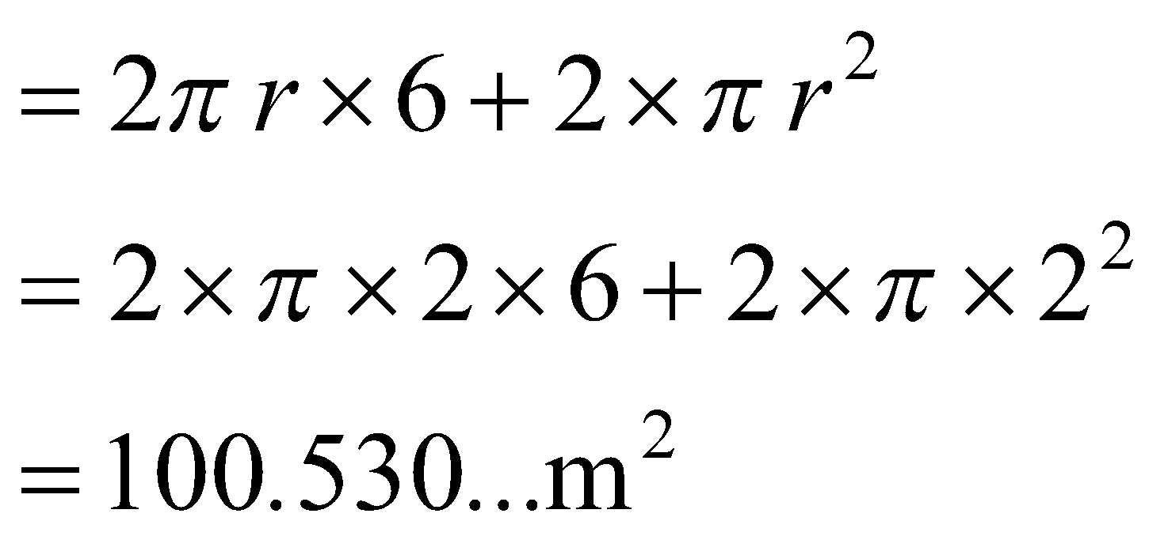
Surface area is 101m² (to the nearest square metre).
(1 mark)

b.
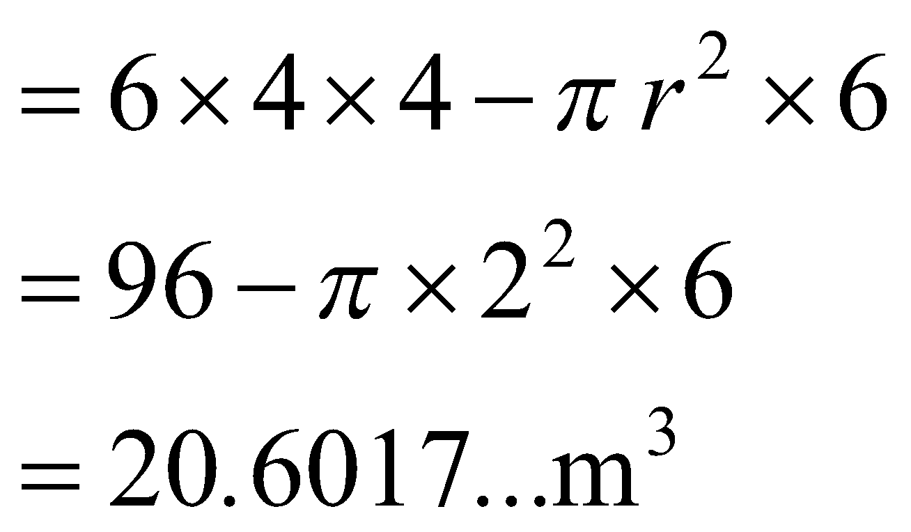
Volume of empty space is 21m³ (to the nearest cubic metre).
(1 mark)

Question 2 (2 marks)
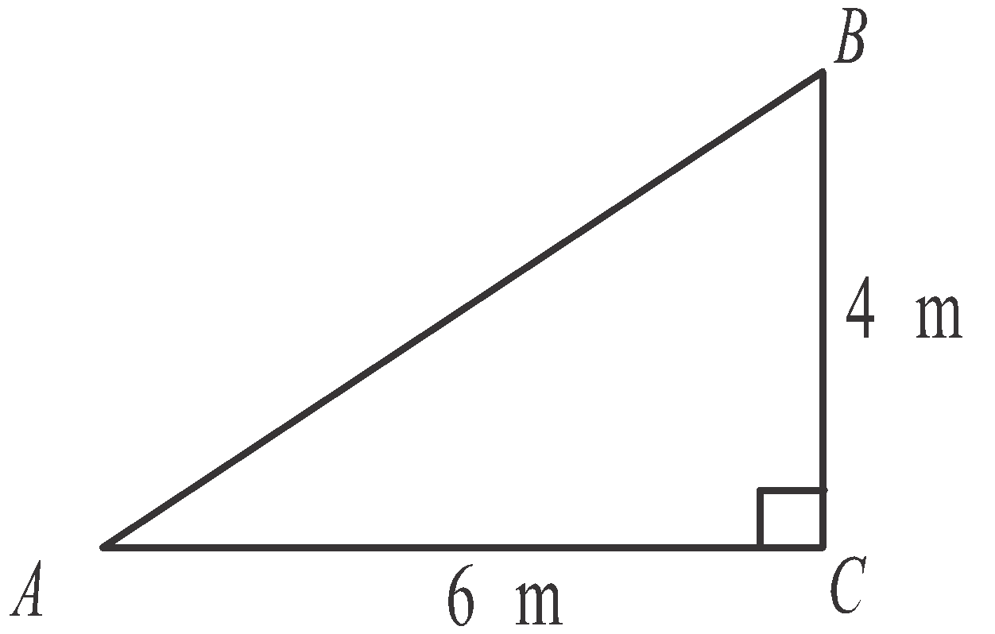
- In ΔABC,
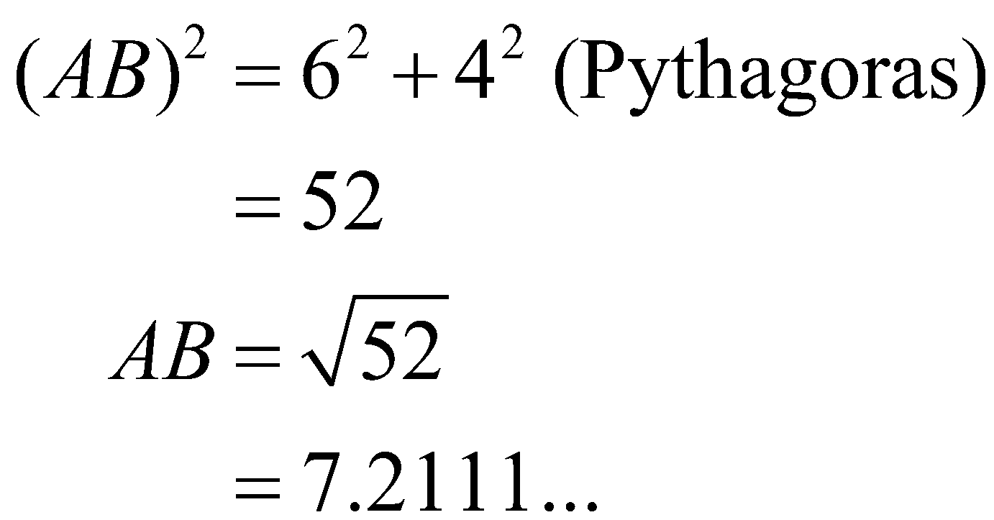
Length of pole is 7.2 m (correct to 2 significant figures).
(1 mark)

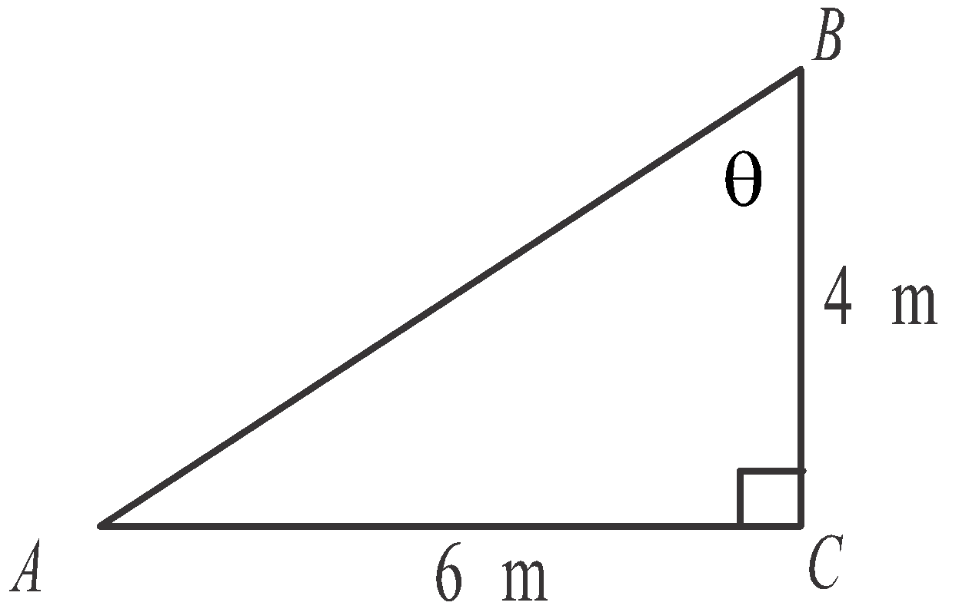
- Again, in ΔABC
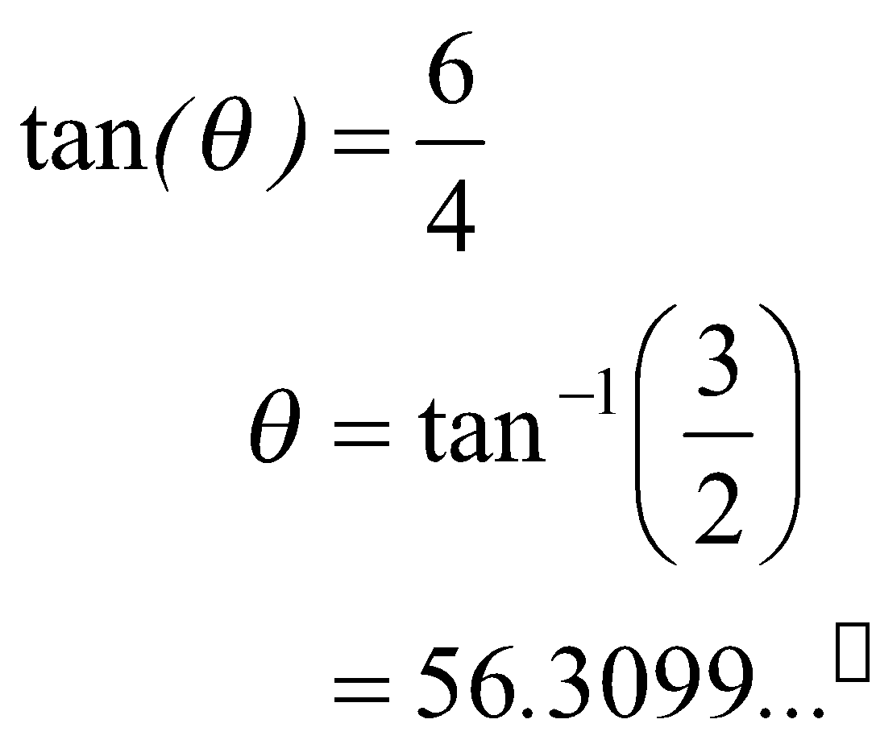
Angle ABC is 56° (to the nearest degree).
(1 mark)

Question 3 (5 marks)
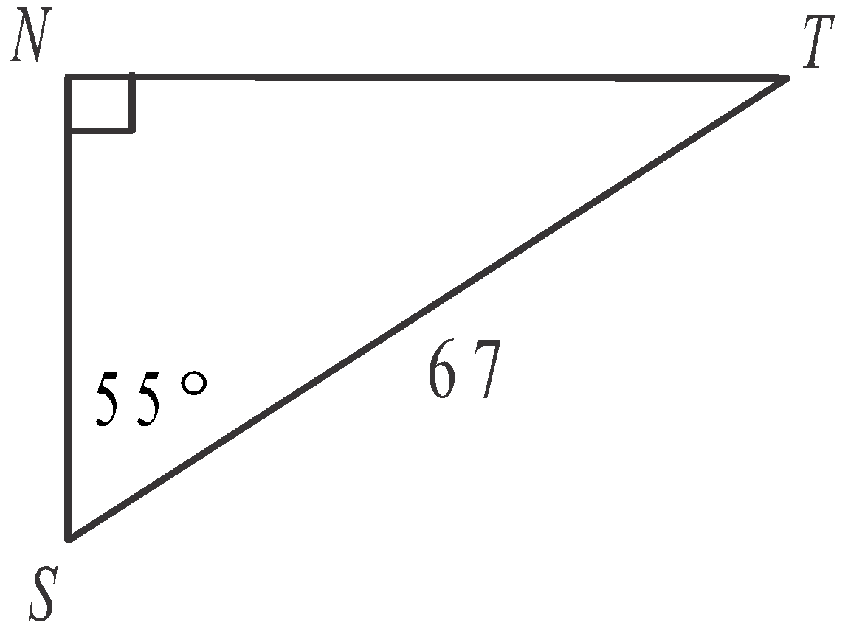
- In ΔNST,
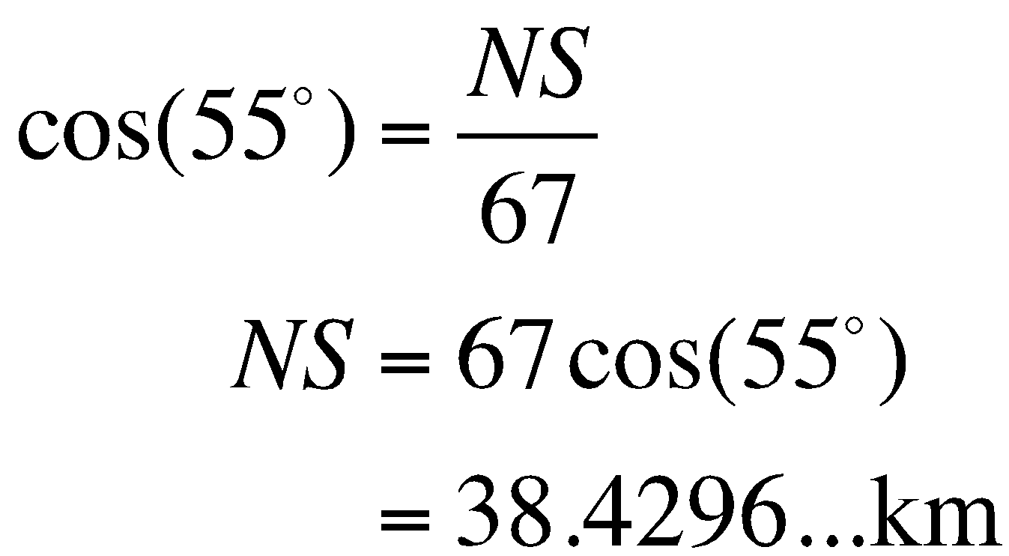
Point T is 38 km (to the nearest kilometre)
north of the ship so the port will also be 38 km north of the ship.
(1 mark)
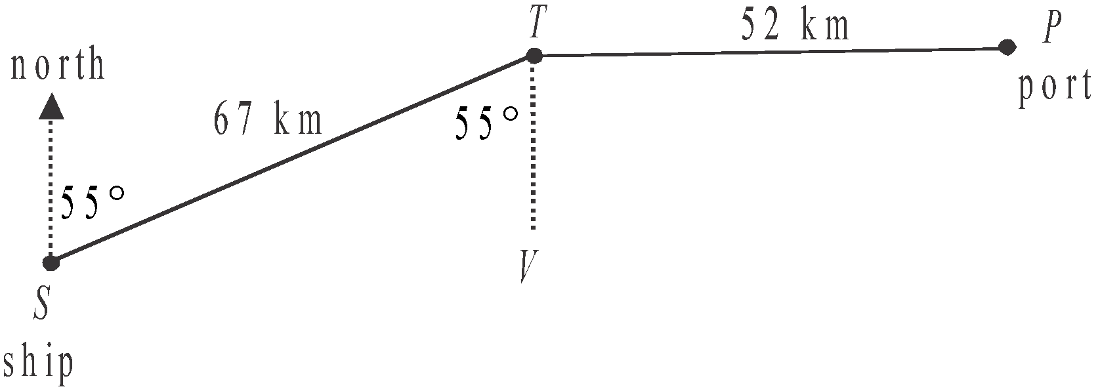

In the diagram above,  (alternate angles).
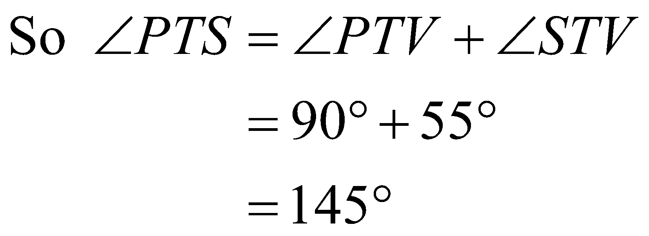
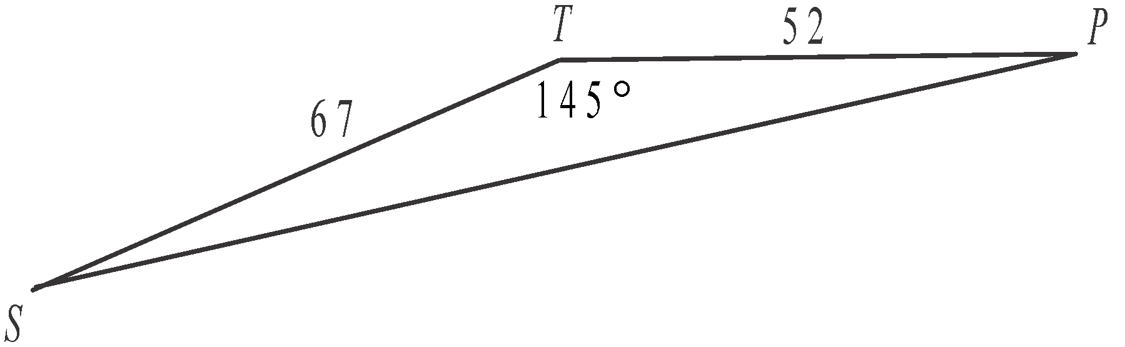
(1 mark)

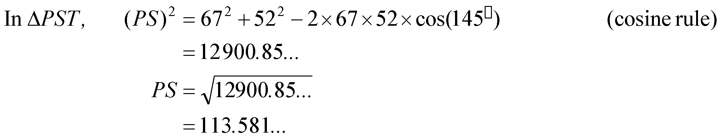
Required distance is 114 km (to the nearest kilometre).
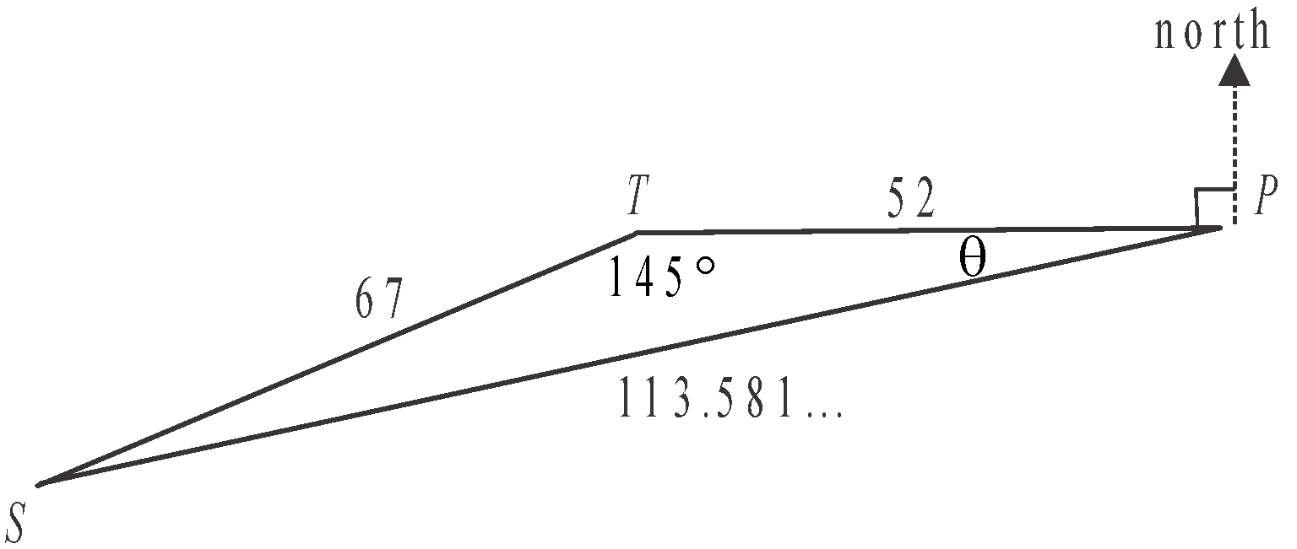
(1 mark)
d.

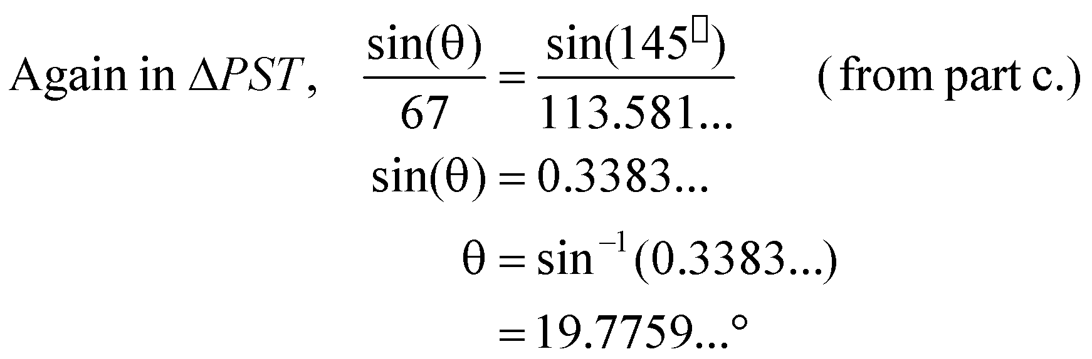
(1 mark)
The bearing of the ship from the port equals 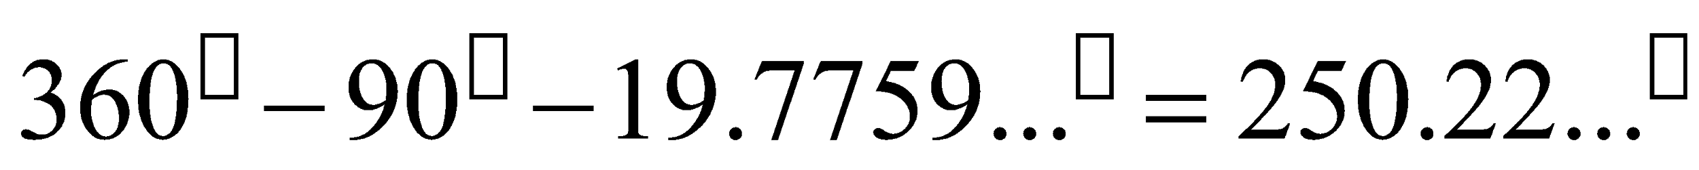 or
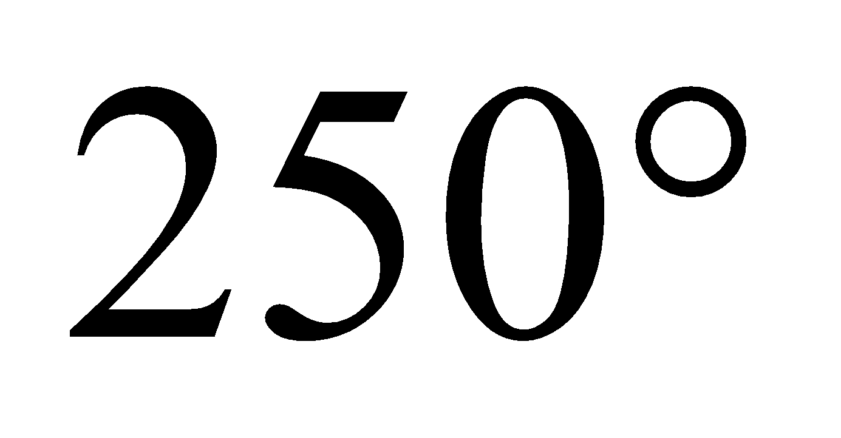 (to the nearest degree). (1 mark)

Question 4 (3 marks)

- Greenwich has longitude 0°.
Pontianak has longitude 110°E.
The difference in longitude is 110°.
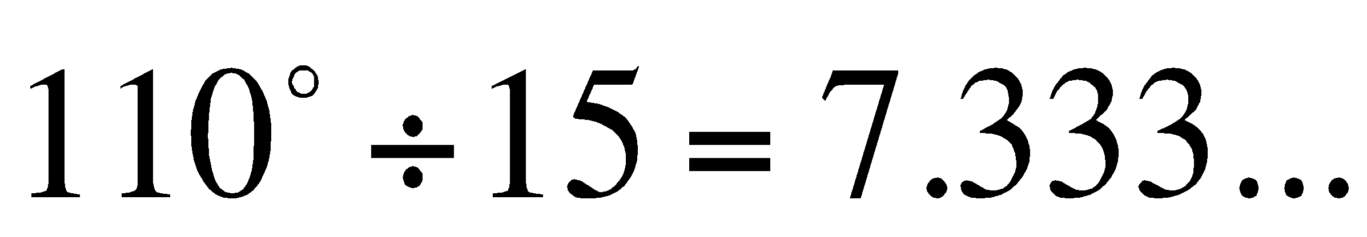
The time difference is 7 hours.
(1 mark)

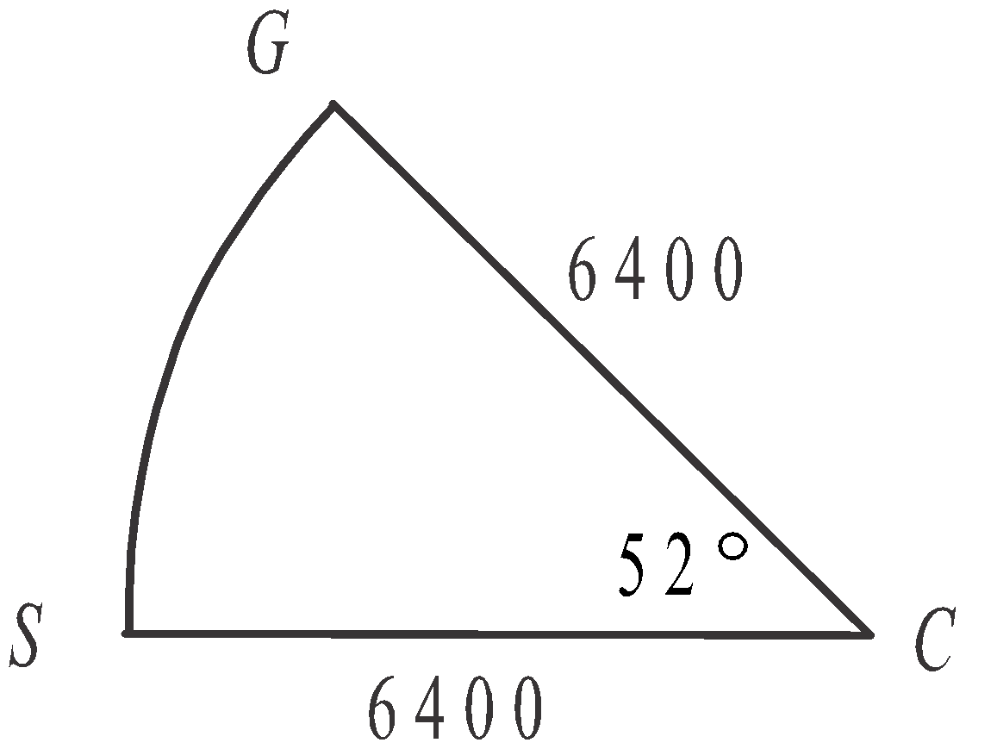
- In the sector CGS, the arc length GS
represents the great circle distance
(along the meridian of longitude 0°)
between Greenwich and the ship.
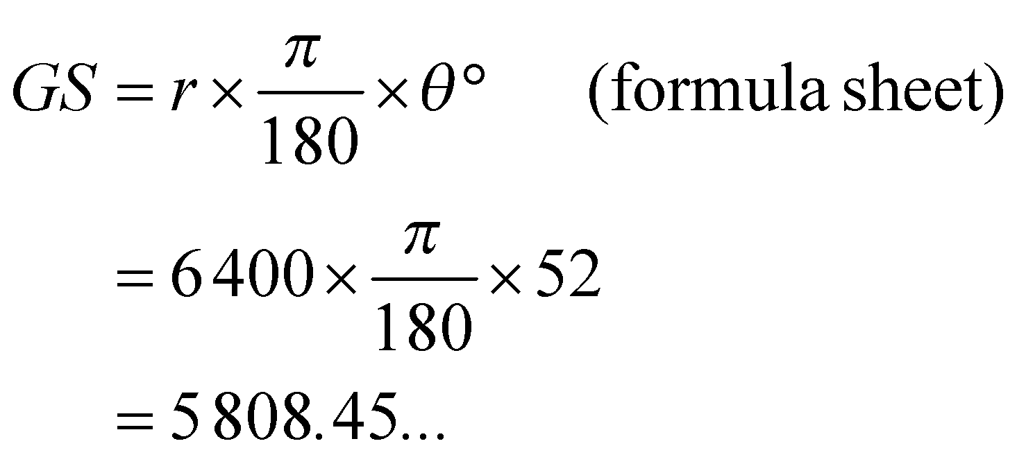
Distance required is 5808 km (to the nearest kilometre).
(1 mark)

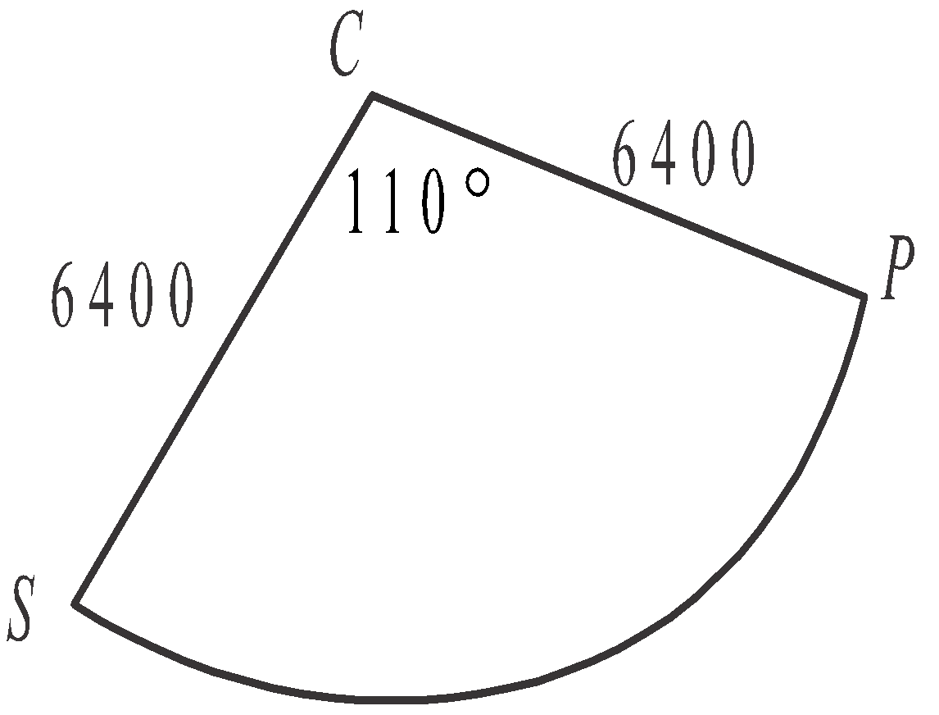
- In the sector CPS, the arc length PS represents
the great circle distance (around the
equator) between the ship and Pontianak.
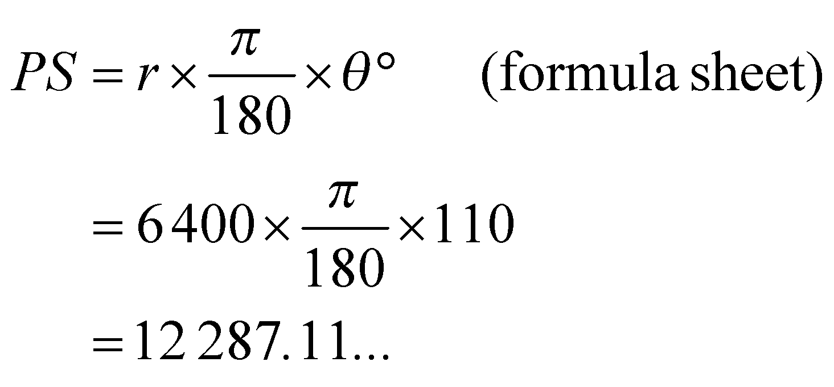
Distance required is 12 287 km (to the nearest kilometre).
(1 mark)
Module 4: Graphs and relations

Question 1 (6 marks)

- Looking at the step graph we see that 5GB is the maximum amount of data that can be obtained for $20.
(1 mark)
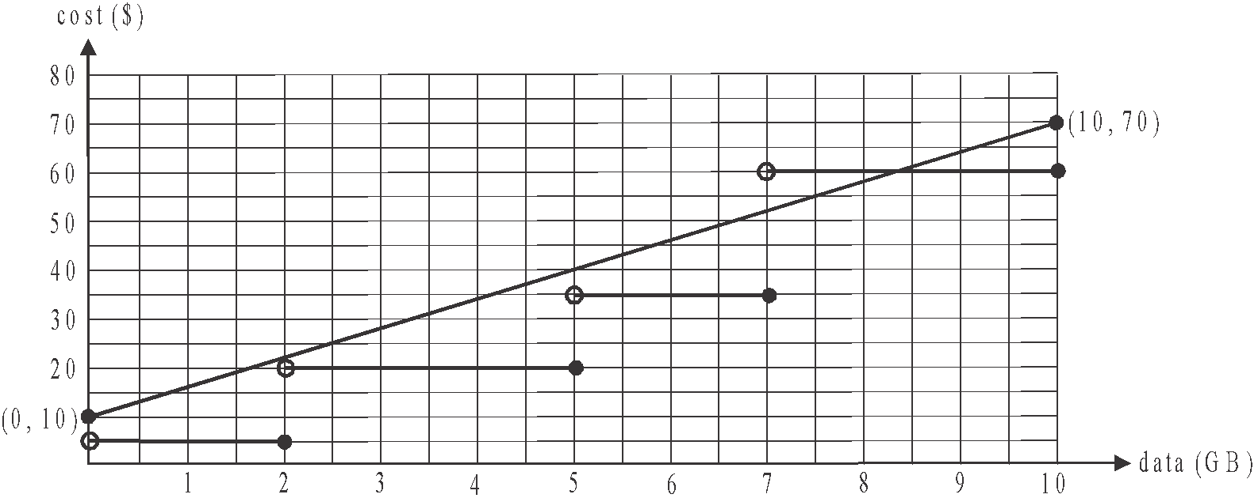

(1 mark) – correct line and correct endpoints
at (0,10) and (10, 70)

- The intercept occurs at (0,10). With Bellstra’s package, even if you don’t use any additional data in a month, you will still pay $10.
(1 mark)

- We are looking for the gradient or slope of the straight line graph. The equation tells us this. Since , the gradient is 6 (think 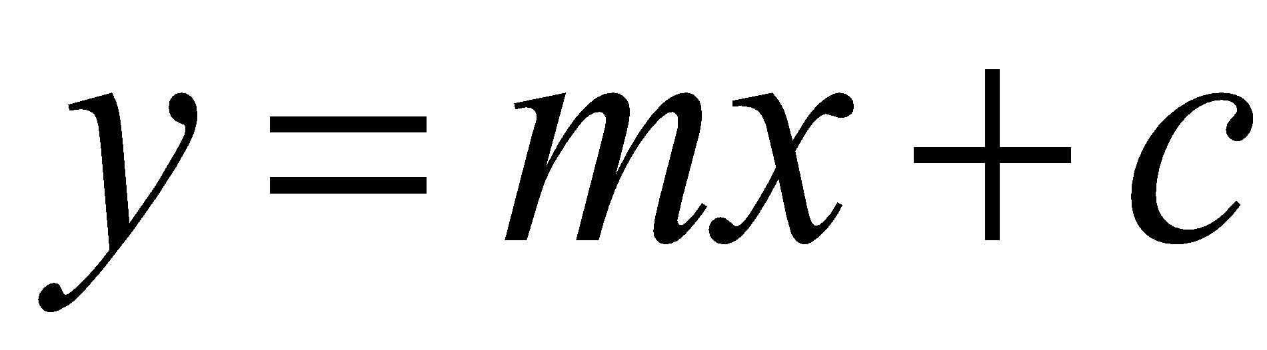 where y is cost, m is gradient which is 6, x is data and 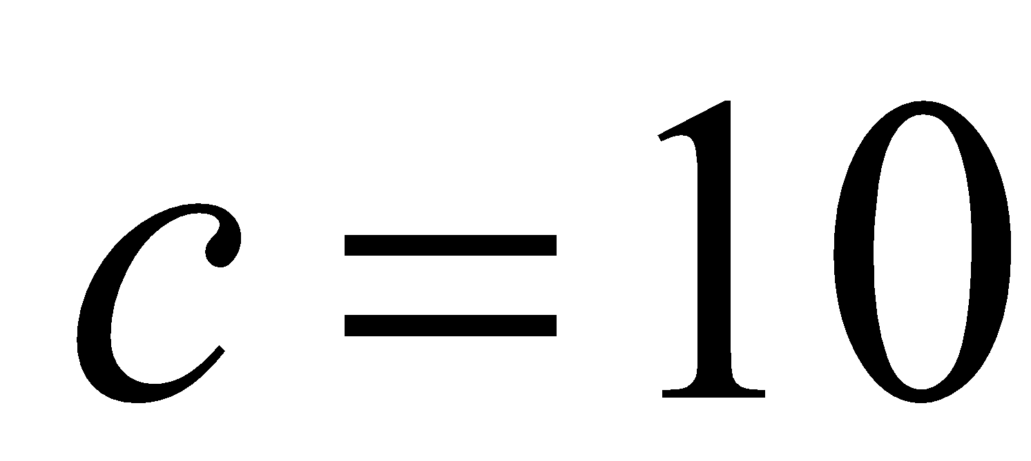).
So each additional gigabyte of data costs $6.
(1 mark)

- With the Talkeasy package, an additional 7GB of data will cost $35.
With the Bellstra package, an additional 7GB of data will be given by 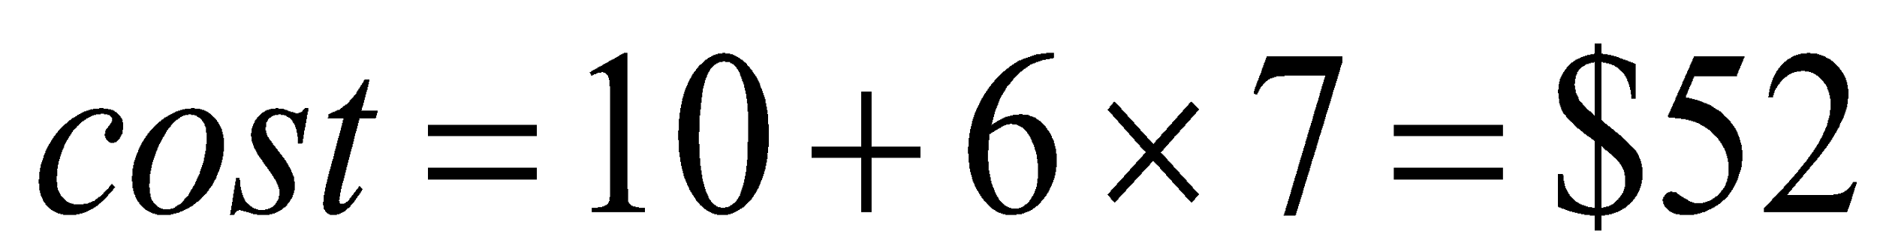. The Talkeasy package is the better package for this customer because it is $17 cheaper than the Bellstra package.
(1 mark)

- The graphs of the cost of the two packages intersect where the cost of Talkeasy’s package is $60. Substitute  into Bellstra’s cost equation
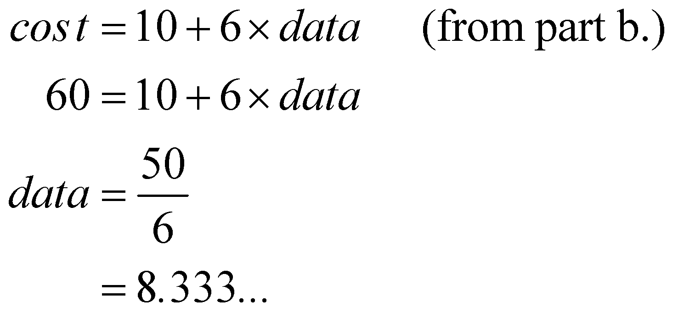
Barry and Tony each used 8.3GB of additional data (correct to one decimal place).
(1 mark)

Question 2 (6 marks)

- This fourth constraint given by the inequality 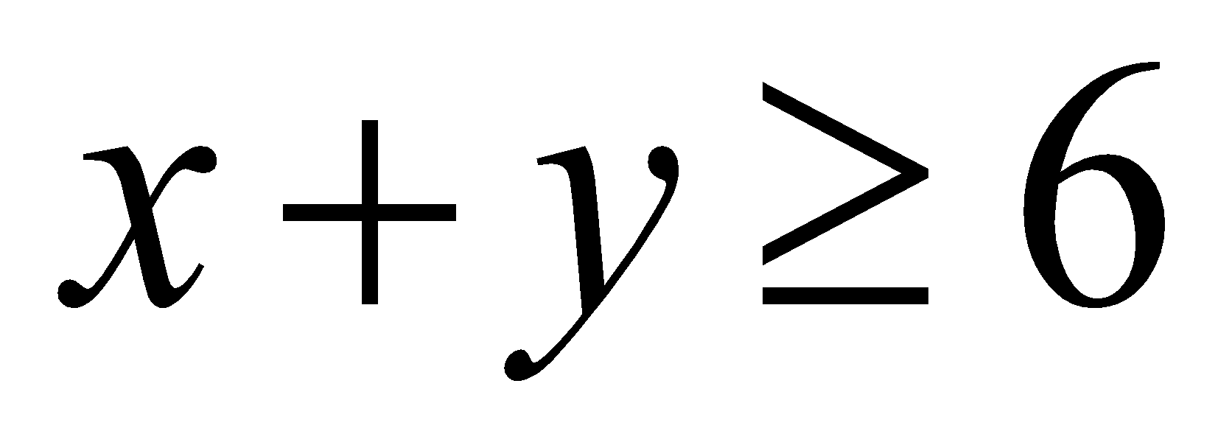, means that the total number of smart phones and laptops available for use in the business must be at least six.
(1 mark)

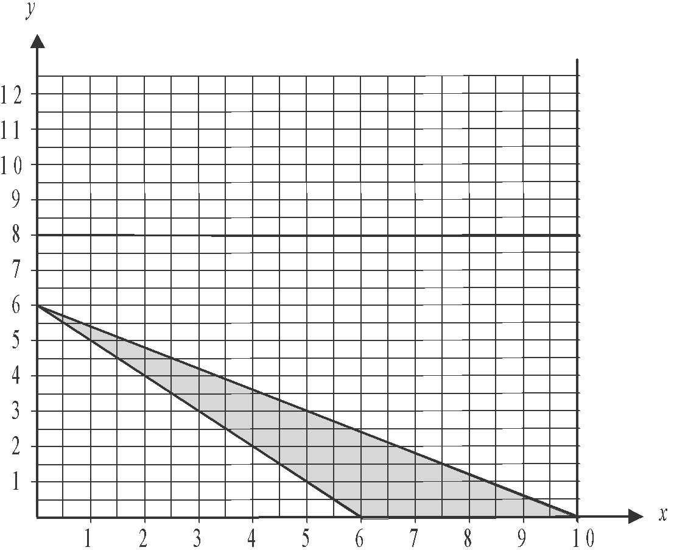

(1 mark)

- Looking at the feasible region of the graph which is shaded in part b., we see that if the business has 4 smart phones available for use, it can have 2 laptops or 3 laptops available for use. So the maximum number of laptops available for use is 3.
(1 mark)

- 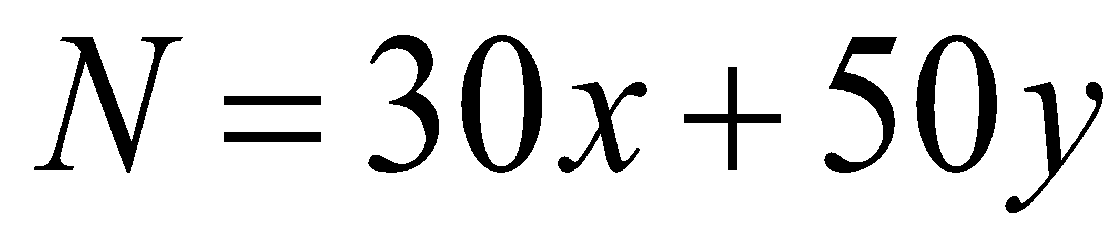
(1 mark)

- Looking at the feasible region of the graph, we see that the corner points occur at the points (0,6), (6,0) and (10,0).
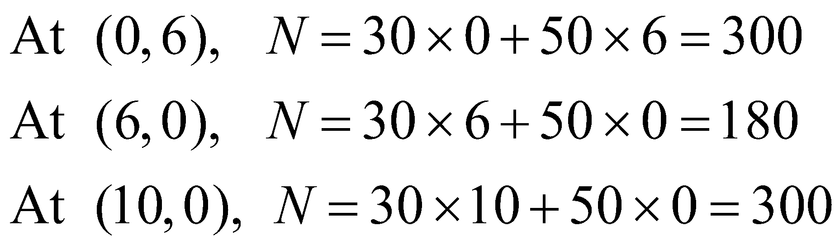
So the maximum number of new clients that be reached each month is 300.
(1 mark)

- The maximum value of N occurs at two corner points of the feasible region i.e. (0,6) and (10,0). This tells us that the maximum value of N occurs along the boundary with equation 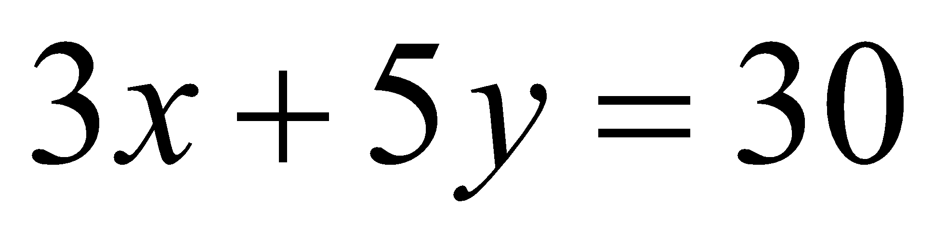. Along this boundary, integer solutions occur at (0,6), (5,3) and (10,0). We are looking for integer (whole number) solutions because it doesn’t make sense to have half a mobile phone or 0.6 of a laptop.
Also, since Stella has said that there must be at least one smart phone and at least one laptop available for use in the business, this eliminates the solutions (0,6) and (10,0). So the business should now have 5 smart phones and 3 laptops available for use.
(1 mark)

